Metanalysis of performance in condition of Stereotype Threat (stThreat)

Geiser C. Challco [geiser@alumni.usp.br](mailto:geiser@alumni.usp.br)

Table of Contents

## Initial Variables and Loading Data

cond <- "stThreat"  
to_remove <- c('S11')  
sub.groups <- c("country","age","ed.level","intervention",  
 "country:age","country:ed.level","country:intervention",  
 "age:intervention","ed.level:intervention",  
 "country:age:intervention","country:ed.level:intervention")

dat <- read_excel("../data/data-without-outliers.xlsx", sheet = "perform-cond-descriptive")  
dat <- dat[!dat$study %in% to_remove, ]  
  
leg <- read_excel("../data/data-without-outliers.xlsx", sheet = "legend")

## New names:  
## • `` -> `...10`

leg <- leg[!leg$study %in% to_remove, ]  
  
idx.e <- which(dat$condition==cond)  
idx.c <- which(dat$condition=="control")  
  
data <- data.frame(  
 study = dat$study[idx.c],  
 n.e = dat$N[idx.e], mean.e = dat$M[idx.e], sd.e = dat$SD[idx.e],  
 n.c = dat$N[idx.c], mean.c = dat$M[idx.c], sd.c = dat$SD[idx.c]  
)  
for (cgroups in strsplit(sub.groups,":")) {  
 data[[paste0(cgroups, collapse = ":")]] <- sapply(data$study, FUN = function(x) {  
 paste0(sapply(cgroups, FUN = function(namecol) leg[[namecol]][which(x == leg$study)]), collapse = ":")  
 })  
}  
data[["lbl"]] <- sapply(data$study, FUN = function(x) leg$Note[which(x == leg$study)])

## Perform meta-analyses

m.cont <- metacont(  
 n.e = n.e, mean.e = mean.e, sd.e = sd.e, n.c = n.c, mean.c = mean.c, sd.c = sd.c,  
 studlab = lbl, data = data, sm = "SMD", method.smd = "Hedges",  
 fixed = F, random = T, method.tau = "REML", hakn = T, title = paste("Performance in",cond)  
)  
summary(m.cont)

## Review: Performance in stThreat  
##   
## SMD 95%-CI %W(random)  
## S1 -0.3302 [-0.8631; 0.2026] 8.2  
## S2 0.0653 [-0.3468; 0.4773] 11.8  
## S3 -0.4150 [-0.9402; 0.1103] 8.4  
## S4 -0.0924 [-0.6256; 0.4408] 8.2  
## S5 0.1959 [-0.2701; 0.6619] 10.0  
## S6 0.2959 [-0.1777; 0.7695] 9.8  
## S7 0.2003 [-0.2012; 0.6017] 12.2  
## S8: Conducted by BNU 0.1809 [-0.3141; 0.6759] 9.2  
## S9: Albuquerque, et al. (2017) -0.4832 [-0.9228; -0.0436] 10.9  
## S10: Only use prompt msgs -0.1663 [-0.5939; 0.2614] 11.3  
##   
## Number of studies combined: k = 10  
## Number of observations: o = 741  
##   
## SMD 95%-CI t p-value  
## Random effects model -0.0434 [-0.2450; 0.1583] -0.49 0.6382  
##   
## Quantifying heterogeneity:  
## tau^2 = 0.0233 [0.0000; 0.2097]; tau = 0.1525 [0.0000; 0.4579]  
## I^2 = 29.0% [0.0%; 66.0%]; H = 1.19 [1.00; 1.72]  
##   
## Test of heterogeneity:  
## Q d.f. p-value  
## 12.68 9 0.1775  
##   
## Details on meta-analytical method:  
## - Inverse variance method  
## - Restricted maximum-likelihood estimator for tau^2  
## - Q-profile method for confidence interval of tau^2 and tau  
## - Hartung-Knapp adjustment for random effects model  
## - Hedges' g (bias corrected standardised mean difference; using exact formulae)

forest(m.cont, digits=2, digits.sd = 2, test.overall = T, label.e = cond)

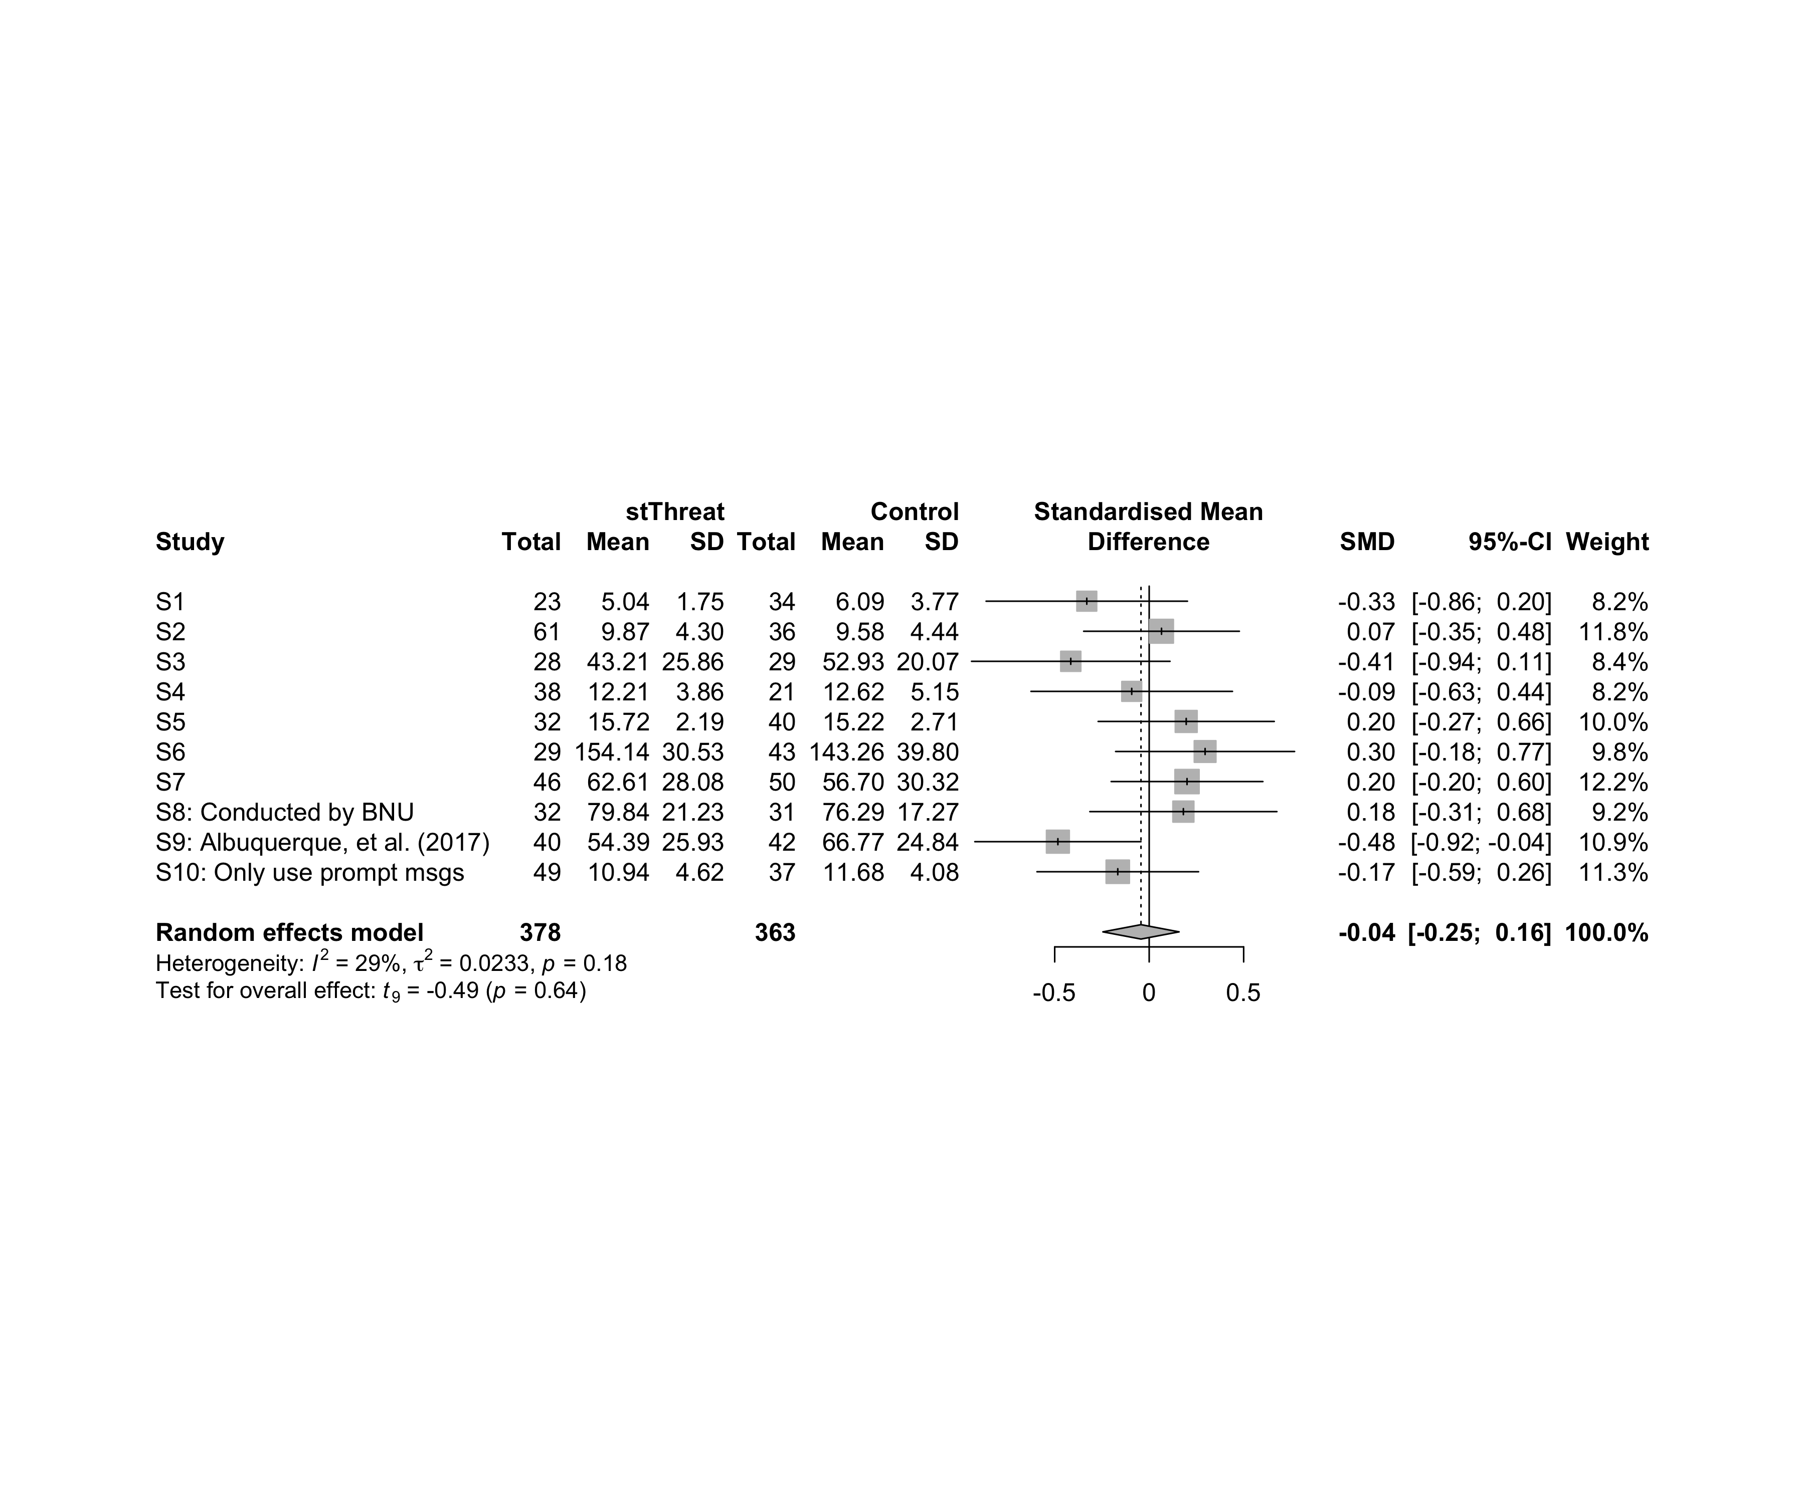

### Subgroup analysis by “country”

m.sg4sub <- update.meta(m.cont, subgroup = country, random = T, fixed = F)  
summary(m.sg4sub)

## Review: Performance in stThreat  
##   
## SMD 95%-CI %W(random) country  
## S1 -0.3302 [-0.8631; 0.2026] 8.2 Brazil  
## S2 0.0653 [-0.3468; 0.4773] 11.8 Brazil  
## S3 -0.4150 [-0.9402; 0.1103] 8.4 Brazil  
## S4 -0.0924 [-0.6256; 0.4408] 8.2 Brazil  
## S5 0.1959 [-0.2701; 0.6619] 10.0 Brazil  
## S6 0.2959 [-0.1777; 0.7695] 9.8 Brazil  
## S7 0.2003 [-0.2012; 0.6017] 12.2 Brazil  
## S8: Conducted by BNU 0.1809 [-0.3141; 0.6759] 9.2 China  
## S9: Albuquerque, et al. (2017) -0.4832 [-0.9228; -0.0436] 10.9 Brazil  
## S10: Only use prompt msgs -0.1663 [-0.5939; 0.2614] 11.3 Brazil  
##   
## Number of studies combined: k = 10  
## Number of observations: o = 741  
##   
## SMD 95%-CI t p-value  
## Random effects model -0.0434 [-0.2450; 0.1583] -0.49 0.6382  
##   
## Quantifying heterogeneity:  
## tau^2 = 0.0233 [0.0000; 0.2097]; tau = 0.1525 [0.0000; 0.4579]  
## I^2 = 29.0% [0.0%; 66.0%]; H = 1.19 [1.00; 1.72]  
##   
## Test of heterogeneity:  
## Q d.f. p-value  
## 12.68 9 0.1775  
##   
## Results for subgroups (random effects model):  
## k SMD 95%-CI tau^2 tau Q I^2  
## country = Brazil 9 -0.0667 [-0.2873; 0.1539] 0.0272 0.1650 11.85 32.5%  
## country = China 1 0.1809 [-0.3141; 0.6759] -- -- 0.00 --  
##   
## Test for subgroup differences (random effects model):  
## Q d.f. p-value  
## Between groups 0.84 1 0.3592  
##   
## Details on meta-analytical method:  
## - Inverse variance method  
## - Restricted maximum-likelihood estimator for tau^2  
## - Q-profile method for confidence interval of tau^2 and tau  
## - Hartung-Knapp adjustment for random effects model  
## - Hedges' g (bias corrected standardised mean difference; using exact formulae)

forest(m.sg4sub, digits=2, digits.sd = 2, test.overall = T, label.e = cond)

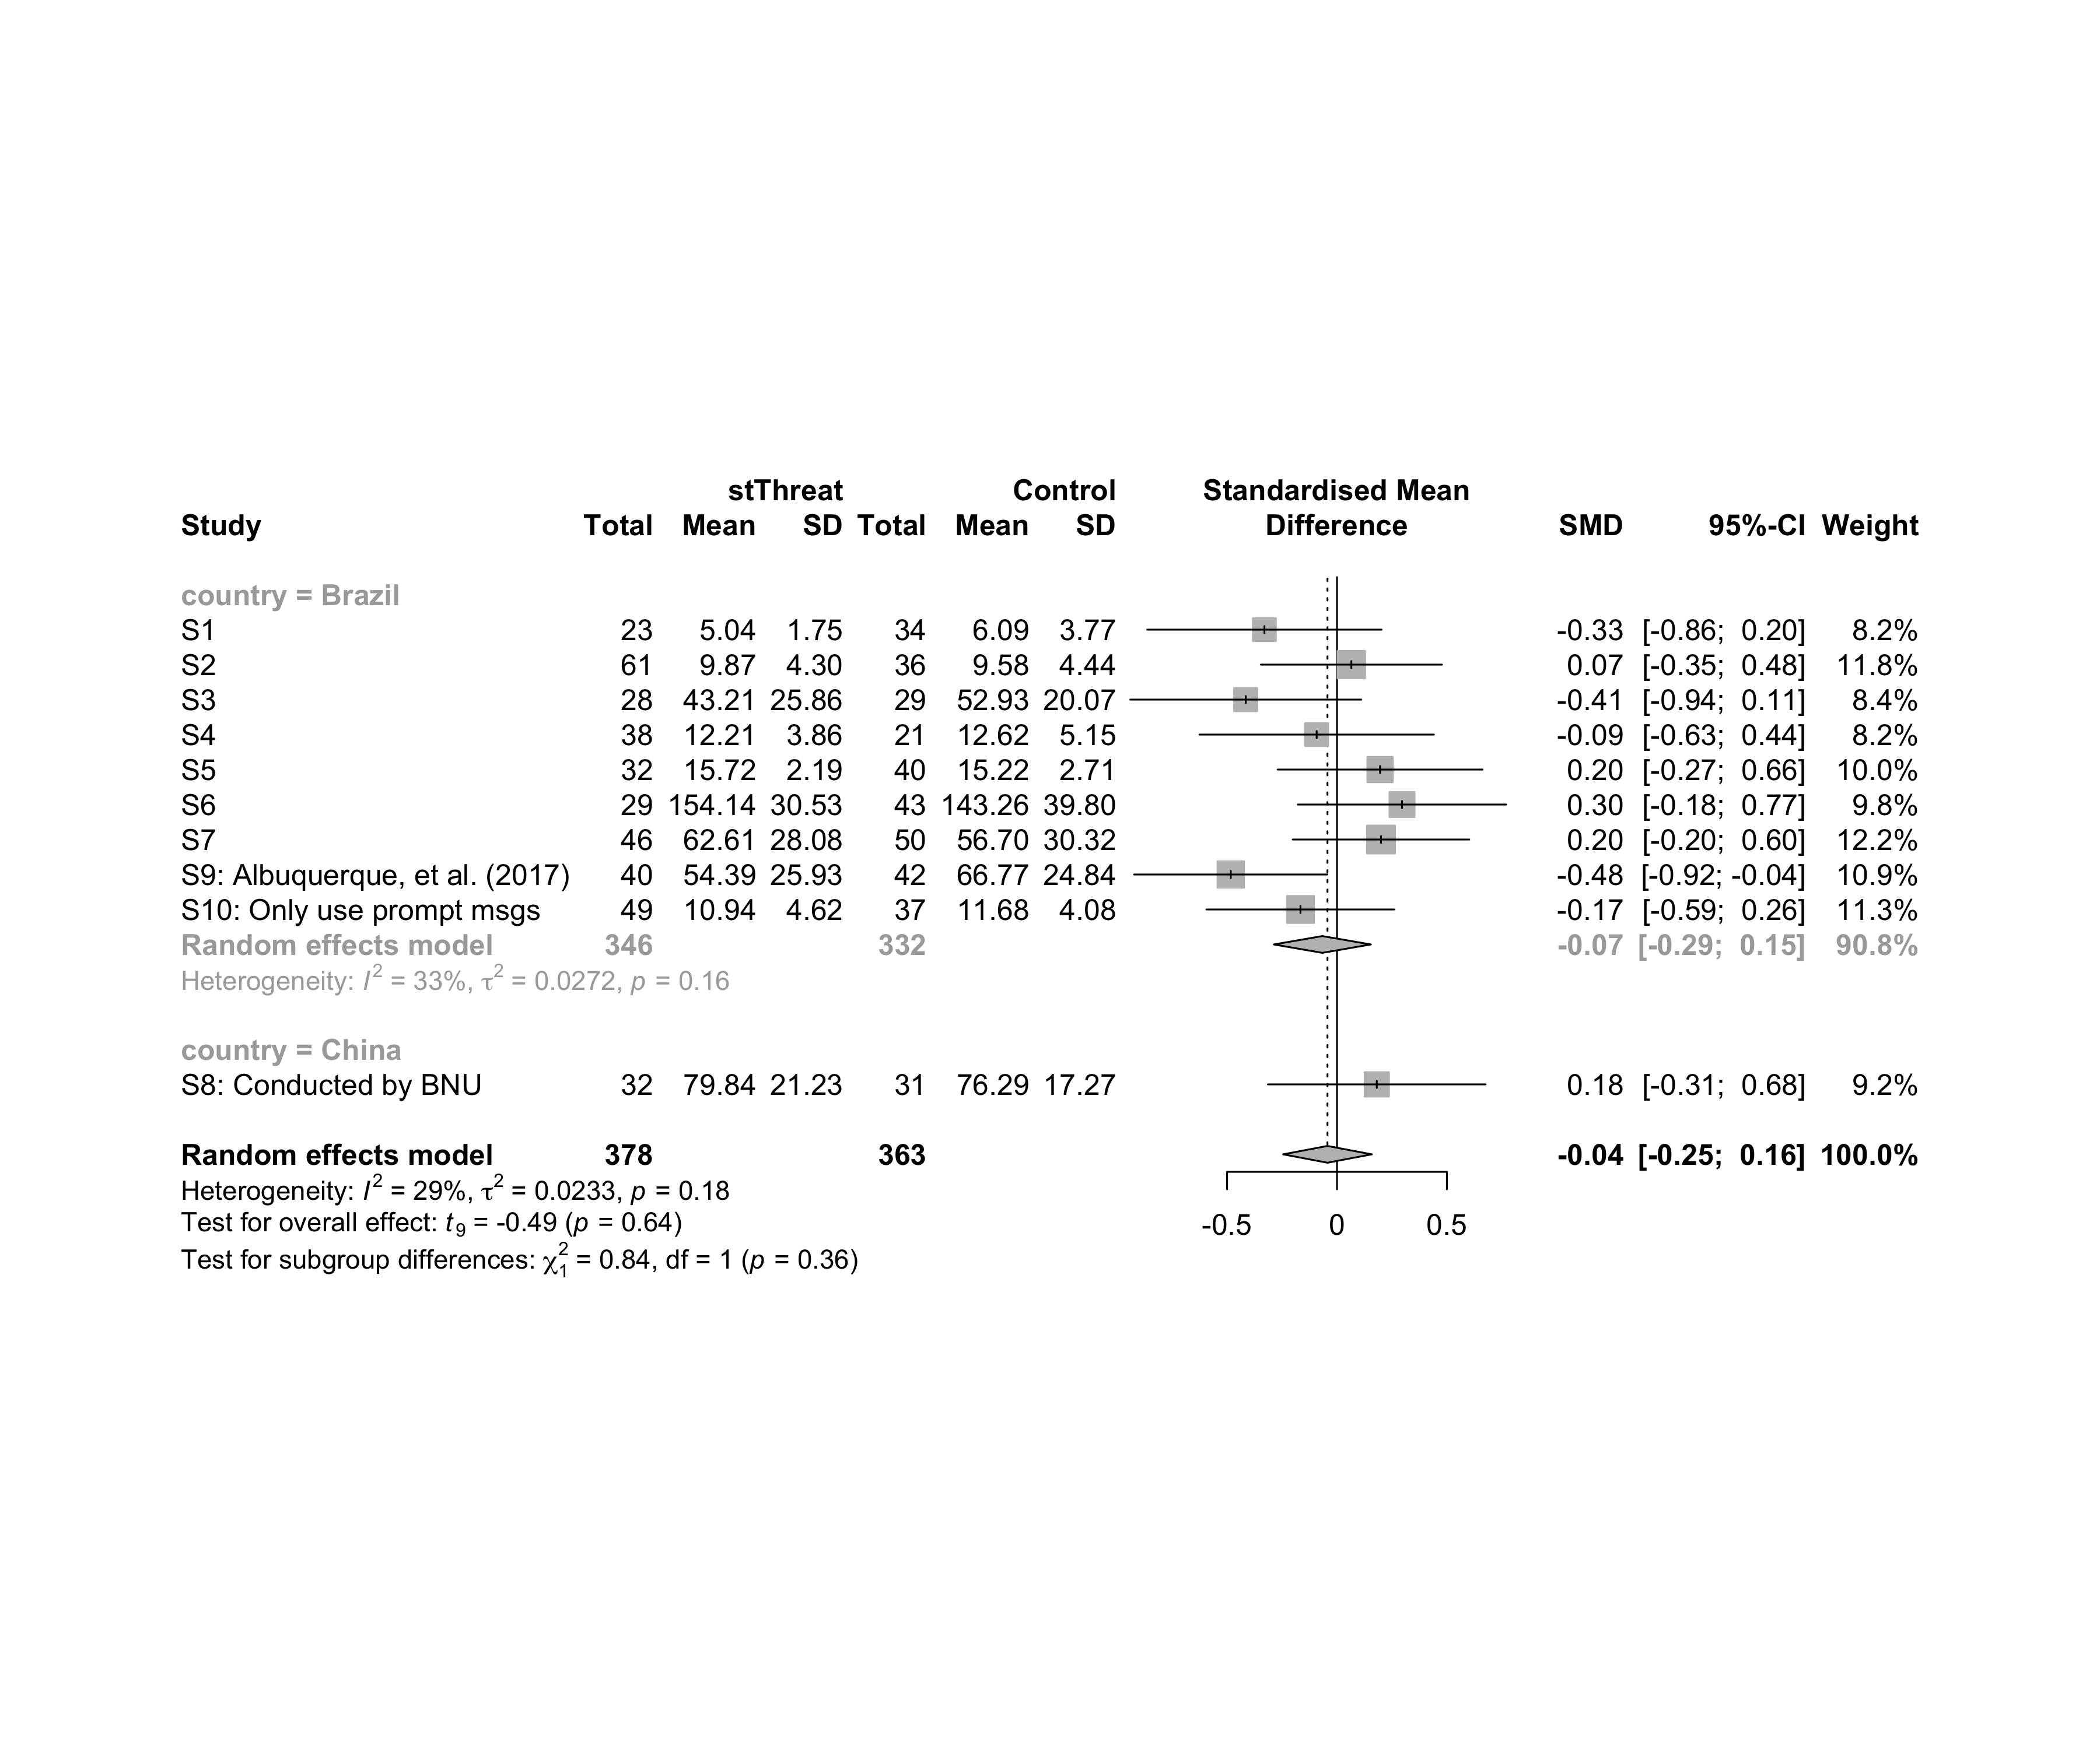

### Subgroup analysis by “age”

m.sg4sub <- update.meta(m.cont, subgroup = country, random = T, fixed = F)  
summary(m.sg4sub)

## Review: Performance in stThreat  
##   
## SMD 95%-CI %W(random) country  
## S1 -0.3302 [-0.8631; 0.2026] 8.2 Brazil  
## S2 0.0653 [-0.3468; 0.4773] 11.8 Brazil  
## S3 -0.4150 [-0.9402; 0.1103] 8.4 Brazil  
## S4 -0.0924 [-0.6256; 0.4408] 8.2 Brazil  
## S5 0.1959 [-0.2701; 0.6619] 10.0 Brazil  
## S6 0.2959 [-0.1777; 0.7695] 9.8 Brazil  
## S7 0.2003 [-0.2012; 0.6017] 12.2 Brazil  
## S8: Conducted by BNU 0.1809 [-0.3141; 0.6759] 9.2 China  
## S9: Albuquerque, et al. (2017) -0.4832 [-0.9228; -0.0436] 10.9 Brazil  
## S10: Only use prompt msgs -0.1663 [-0.5939; 0.2614] 11.3 Brazil  
##   
## Number of studies combined: k = 10  
## Number of observations: o = 741  
##   
## SMD 95%-CI t p-value  
## Random effects model -0.0434 [-0.2450; 0.1583] -0.49 0.6382  
##   
## Quantifying heterogeneity:  
## tau^2 = 0.0233 [0.0000; 0.2097]; tau = 0.1525 [0.0000; 0.4579]  
## I^2 = 29.0% [0.0%; 66.0%]; H = 1.19 [1.00; 1.72]  
##   
## Test of heterogeneity:  
## Q d.f. p-value  
## 12.68 9 0.1775  
##   
## Results for subgroups (random effects model):  
## k SMD 95%-CI tau^2 tau Q I^2  
## country = Brazil 9 -0.0667 [-0.2873; 0.1539] 0.0272 0.1650 11.85 32.5%  
## country = China 1 0.1809 [-0.3141; 0.6759] -- -- 0.00 --  
##   
## Test for subgroup differences (random effects model):  
## Q d.f. p-value  
## Between groups 0.84 1 0.3592  
##   
## Details on meta-analytical method:  
## - Inverse variance method  
## - Restricted maximum-likelihood estimator for tau^2  
## - Q-profile method for confidence interval of tau^2 and tau  
## - Hartung-Knapp adjustment for random effects model  
## - Hedges' g (bias corrected standardised mean difference; using exact formulae)

forest(m.sg4sub, digits=2, digits.sd = 2, test.overall = T, label.e = cond)



### Subgroup analysis by “ed.level”

m.sg4sub <- update.meta(m.cont, subgroup = ed.level, random = T, fixed = F)  
summary(m.sg4sub)

## Review: Performance in stThreat  
##   
## SMD 95%-CI %W(random) ed.level  
## S1 -0.3302 [-0.8631; 0.2026] 8.2 upper-secundary  
## S2 0.0653 [-0.3468; 0.4773] 11.8 upper-secundary  
## S3 -0.4150 [-0.9402; 0.1103] 8.4 upper-secundary  
## S4 -0.0924 [-0.6256; 0.4408] 8.2 higher-education  
## S5 0.1959 [-0.2701; 0.6619] 10.0 higher-education  
## S6 0.2959 [-0.1777; 0.7695] 9.8 higher-education  
## S7 0.2003 [-0.2012; 0.6017] 12.2 unknown  
## S8: Conducted by BNU 0.1809 [-0.3141; 0.6759] 9.2 unknown  
## S9: Albuquerque, et al. (2017) -0.4832 [-0.9228; -0.0436] 10.9 unknown  
## S10: Only use prompt msgs -0.1663 [-0.5939; 0.2614] 11.3 upper-secundary  
##   
## Number of studies combined: k = 10  
## Number of observations: o = 741  
##   
## SMD 95%-CI t p-value  
## Random effects model -0.0434 [-0.2450; 0.1583] -0.49 0.6382  
##   
## Quantifying heterogeneity:  
## tau^2 = 0.0233 [0.0000; 0.2097]; tau = 0.1525 [0.0000; 0.4579]  
## I^2 = 29.0% [0.0%; 66.0%]; H = 1.19 [1.00; 1.72]  
##   
## Test of heterogeneity:  
## Q d.f. p-value  
## 12.68 9 0.1775  
##   
## Results for subgroups (random effects model):  
## k SMD 95%-CI tau^2 tau Q I^2  
## ed.level = upper-secundary 4 -0.1725 [-0.5126; 0.1676] 0 0 2.44 0.0%  
## ed.level = higher-education 3 0.1507 [-0.3279; 0.6294] 0 0 1.20 0.0%  
## ed.level = unknown 3 -0.0353 [-1.0048; 0.9342] 0.1022 0.3197 6.04 66.9%  
##   
## Test for subgroup differences (random effects model):  
## Q d.f. p-value  
## Between groups 4.40 2 0.1110  
##   
## Details on meta-analytical method:  
## - Inverse variance method  
## - Restricted maximum-likelihood estimator for tau^2  
## - Q-profile method for confidence interval of tau^2 and tau  
## - Hartung-Knapp adjustment for random effects model  
## - Hedges' g (bias corrected standardised mean difference; using exact formulae)

forest(m.sg4sub, digits=2, digits.sd = 2, test.overall = T, label.e = cond)

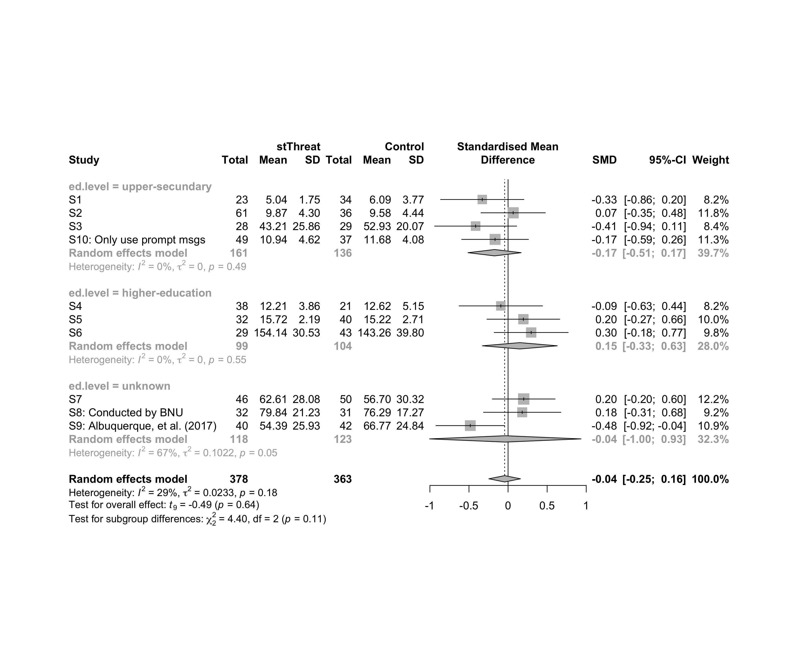

### Subgroup analysis by “intervention”

m.sg4sub <- update.meta(m.cont, subgroup = `intervention`, random = T, fixed = F)  
summary(m.sg4sub)

## Review: Performance in stThreat  
##   
## SMD 95%-CI %W(random)  
## S1 -0.3302 [-0.8631; 0.2026] 8.2  
## S2 0.0653 [-0.3468; 0.4773] 11.8  
## S3 -0.4150 [-0.9402; 0.1103] 8.4  
## S4 -0.0924 [-0.6256; 0.4408] 8.2  
## S5 0.1959 [-0.2701; 0.6619] 10.0  
## S6 0.2959 [-0.1777; 0.7695] 9.8  
## S7 0.2003 [-0.2012; 0.6017] 12.2  
## S8: Conducted by BNU 0.1809 [-0.3141; 0.6759] 9.2  
## S9: Albuquerque, et al. (2017) -0.4832 [-0.9228; -0.0436] 10.9  
## S10: Only use prompt msgs -0.1663 [-0.5939; 0.2614] 11.3  
## intervention  
## S1 Gender-stereotype color, ranking, badges, and avatar  
## S2 Gender-stereotype color, ranking, badges, and avatar  
## S3 Gender-stereotype color, ranking, badges, and avatar  
## S4 Gender-stereotype color, ranking, badges, and avatar  
## S5 Gender-stereotype color, ranking, badges, and avatar  
## S6 Gender-stereotype color, ranking, badges, and avatar  
## S7 Gender-stereotype color, ranking, badges, and avatar  
## S8: Conducted by BNU Gender-stereotype color, ranking, badges, and avatar  
## S9: Albuquerque, et al. (2017) Gender-stereotype color, ranking, badges, and avatar  
## S10: Only use prompt msgs Gender-stereotyped motivational message prompts  
##   
## Number of studies combined: k = 10  
## Number of observations: o = 741  
##   
## SMD 95%-CI t p-value  
## Random effects model -0.0434 [-0.2450; 0.1583] -0.49 0.6382  
##   
## Quantifying heterogeneity:  
## tau^2 = 0.0233 [0.0000; 0.2097]; tau = 0.1525 [0.0000; 0.4579]  
## I^2 = 29.0% [0.0%; 66.0%]; H = 1.19 [1.00; 1.72]  
##   
## Test of heterogeneity:  
## Q d.f. p-value  
## 12.68 9 0.1775  
##   
## Results for subgroups (random effects model):  
## k SMD 95%-CI tau^2 tau Q I^2  
## intervention = Gender-stereotype color, rankin ... 9 -0.0290 [-0.2575; 0.1994] 0.0313 0.1768 12.30 34.9%  
## intervention = Gender-stereotyped motivational ... 1 -0.1663 [-0.5939; 0.2614] -- -- 0.00 --  
##   
## Test for subgroup differences (random effects model):  
## Q d.f. p-value  
## Between groups 0.33 1 0.5668  
##   
## Details on meta-analytical method:  
## - Inverse variance method  
## - Restricted maximum-likelihood estimator for tau^2  
## - Q-profile method for confidence interval of tau^2 and tau  
## - Hartung-Knapp adjustment for random effects model  
## - Hedges' g (bias corrected standardised mean difference; using exact formulae)

forest(m.sg4sub, digits=2, digits.sd = 2, test.overall = T, label.e = cond)

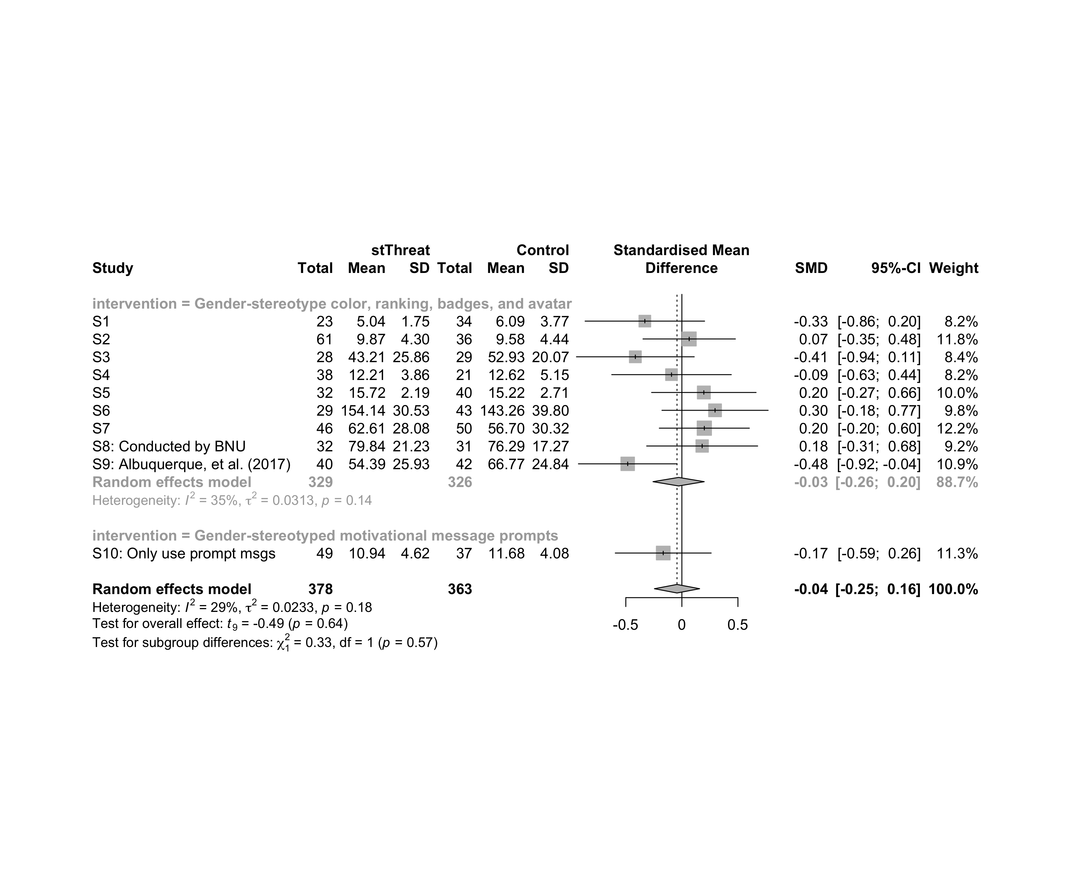

### Subgroup analysis by “country:age”

m.sg4sub <- update.meta(m.cont, subgroup = `country:age`, random = T, fixed = F)  
summary(m.sg4sub)

## Review: Performance in stThreat  
##   
## SMD 95%-CI %W(random) country:age  
## S1 -0.3302 [-0.8631; 0.2026] 8.2 Brazil:adolescent  
## S2 0.0653 [-0.3468; 0.4773] 11.8 Brazil:adolescent  
## S3 -0.4150 [-0.9402; 0.1103] 8.4 Brazil:adolescent  
## S4 -0.0924 [-0.6256; 0.4408] 8.2 Brazil:adult  
## S5 0.1959 [-0.2701; 0.6619] 10.0 Brazil:adult  
## S6 0.2959 [-0.1777; 0.7695] 9.8 Brazil:adult  
## S7 0.2003 [-0.2012; 0.6017] 12.2 Brazil:adult  
## S8: Conducted by BNU 0.1809 [-0.3141; 0.6759] 9.2 China:no-restriction  
## S9: Albuquerque, et al. (2017) -0.4832 [-0.9228; -0.0436] 10.9 Brazil:no-restriction  
## S10: Only use prompt msgs -0.1663 [-0.5939; 0.2614] 11.3 Brazil:adolescence  
##   
## Number of studies combined: k = 10  
## Number of observations: o = 741  
##   
## SMD 95%-CI t p-value  
## Random effects model -0.0434 [-0.2450; 0.1583] -0.49 0.6382  
##   
## Quantifying heterogeneity:  
## tau^2 = 0.0233 [0.0000; 0.2097]; tau = 0.1525 [0.0000; 0.4579]  
## I^2 = 29.0% [0.0%; 66.0%]; H = 1.19 [1.00; 1.72]  
##   
## Test of heterogeneity:  
## Q d.f. p-value  
## 12.68 9 0.1775  
##   
## Results for subgroups (random effects model):  
## k SMD 95%-CI tau^2 tau Q I^2  
## country:age = Brazil:adolescent 3 -0.1887 [-0.8543; 0.4770] 0.0191 0.1382 2.43 17.8%  
## country:age = Brazil:adult 4 0.1671 [-0.0733; 0.4075] 0 0 1.24 0.0%  
## country:age = China:no-restriction 1 0.1809 [-0.3141; 0.6759] -- -- 0.00 --  
## country:age = Brazil:no-restriction 1 -0.4832 [-0.9228; -0.0436] -- -- 0.00 --  
## country:age = Brazil:adolescence 1 -0.1663 [-0.5939; 0.2614] -- -- 0.00 --  
##   
## Test for subgroup differences (random effects model):  
## Q d.f. p-value  
## Between groups 11.66 4 0.0200  
##   
## Details on meta-analytical method:  
## - Inverse variance method  
## - Restricted maximum-likelihood estimator for tau^2  
## - Q-profile method for confidence interval of tau^2 and tau  
## - Hartung-Knapp adjustment for random effects model  
## - Hedges' g (bias corrected standardised mean difference; using exact formulae)

forest(m.sg4sub, digits=2, digits.sd = 2, test.overall = T, label.e = cond)

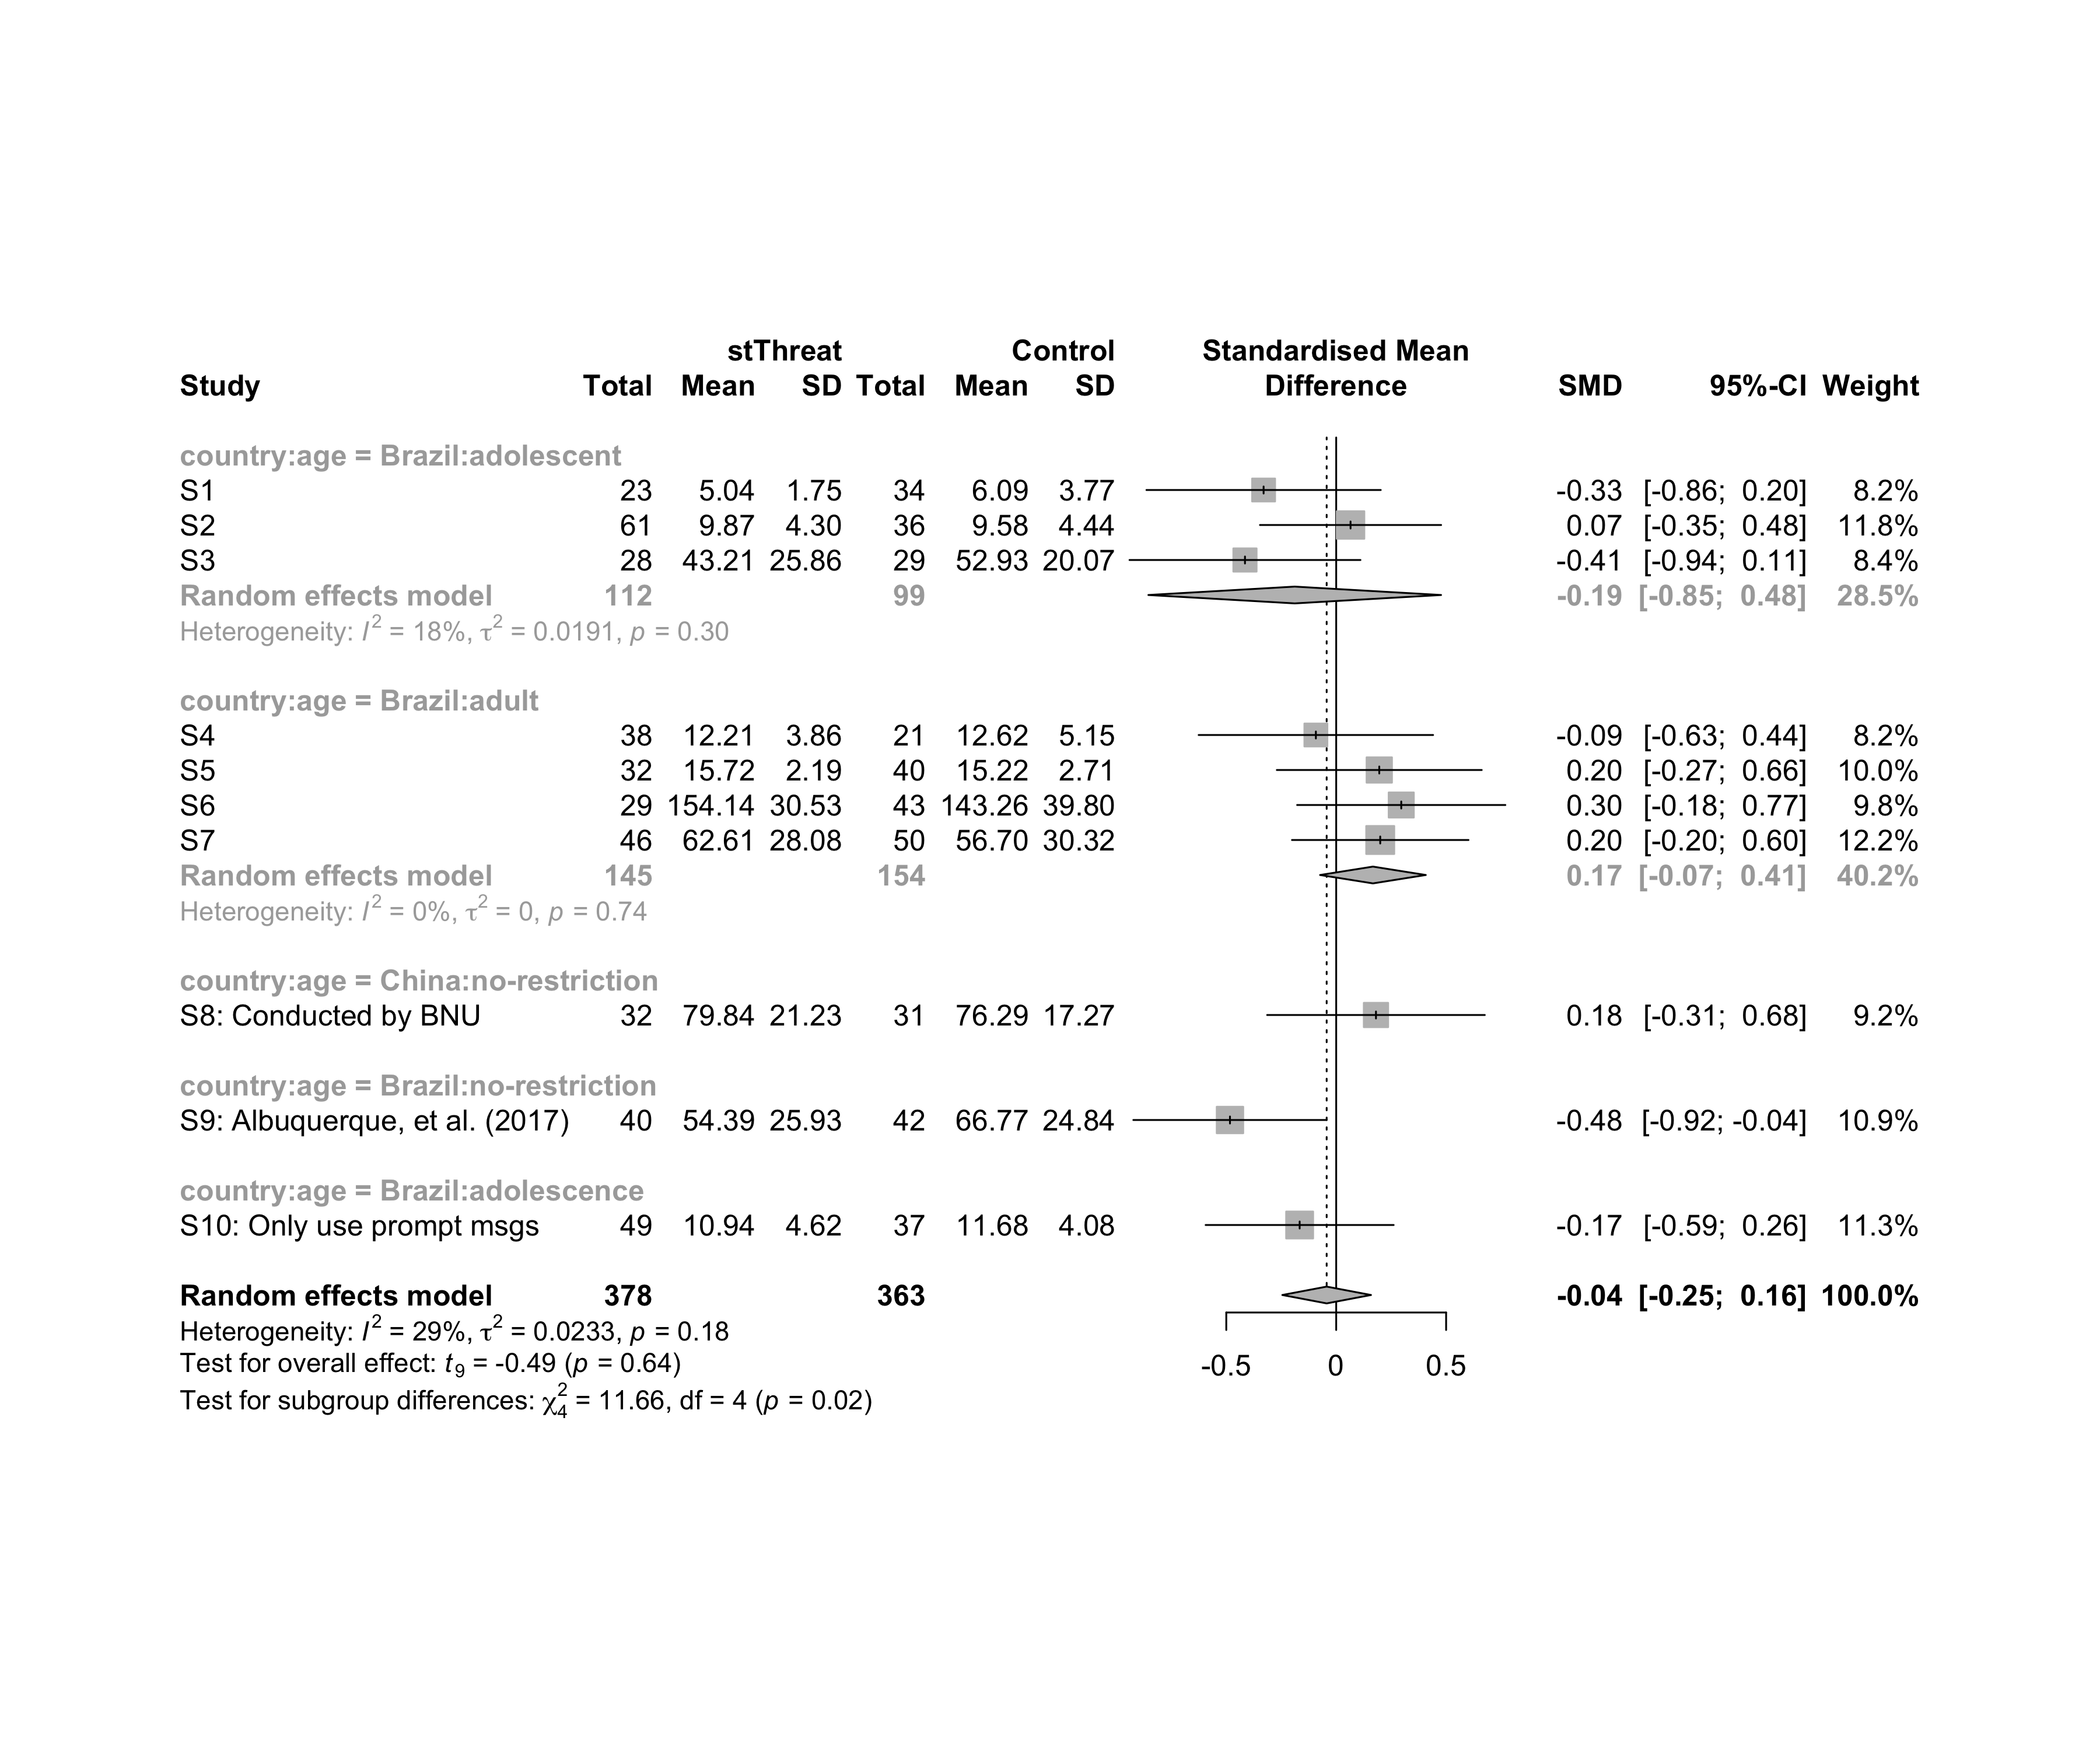

### Subgroup analysis by “country:ed.level”

m.sg4sub <- update.meta(m.cont, subgroup = `country:ed.level`, random = T, fixed = F)  
summary(m.sg4sub)

## Review: Performance in stThreat  
##   
## SMD 95%-CI %W(random) country:ed.level  
## S1 -0.3302 [-0.8631; 0.2026] 8.2 Brazil:upper-secundary  
## S2 0.0653 [-0.3468; 0.4773] 11.8 Brazil:upper-secundary  
## S3 -0.4150 [-0.9402; 0.1103] 8.4 Brazil:upper-secundary  
## S4 -0.0924 [-0.6256; 0.4408] 8.2 Brazil:higher-education  
## S5 0.1959 [-0.2701; 0.6619] 10.0 Brazil:higher-education  
## S6 0.2959 [-0.1777; 0.7695] 9.8 Brazil:higher-education  
## S7 0.2003 [-0.2012; 0.6017] 12.2 Brazil:unknown  
## S8: Conducted by BNU 0.1809 [-0.3141; 0.6759] 9.2 China:unknown  
## S9: Albuquerque, et al. (2017) -0.4832 [-0.9228; -0.0436] 10.9 Brazil:unknown  
## S10: Only use prompt msgs -0.1663 [-0.5939; 0.2614] 11.3 Brazil:upper-secundary  
##   
## Number of studies combined: k = 10  
## Number of observations: o = 741  
##   
## SMD 95%-CI t p-value  
## Random effects model -0.0434 [-0.2450; 0.1583] -0.49 0.6382  
##   
## Quantifying heterogeneity:  
## tau^2 = 0.0233 [0.0000; 0.2097]; tau = 0.1525 [0.0000; 0.4579]  
## I^2 = 29.0% [0.0%; 66.0%]; H = 1.19 [1.00; 1.72]  
##   
## Test of heterogeneity:  
## Q d.f. p-value  
## 12.68 9 0.1775  
##   
## Results for subgroups (random effects model):  
## k SMD 95%-CI tau^2 tau Q I^2  
## country:ed.level = Brazil:upper-secundary 4 -0.1725 [-0.5126; 0.1676] 0 0 2.44 0.0%  
## country:ed.level = Brazil:higher-education 3 0.1507 [-0.3279; 0.6294] 0 0 1.20 0.0%  
## country:ed.level = Brazil:unknown 2 -0.1353 [-4.4768; 4.2061] 0.1874 0.4329 5.06 80.3%  
## country:ed.level = China:unknown 1 0.1809 [-0.3141; 0.6759] -- -- 0.00 --  
##   
## Test for subgroup differences (random effects model):  
## Q d.f. p-value  
## Between groups 5.10 3 0.1643  
##   
## Details on meta-analytical method:  
## - Inverse variance method  
## - Restricted maximum-likelihood estimator for tau^2  
## - Q-profile method for confidence interval of tau^2 and tau  
## - Hartung-Knapp adjustment for random effects model  
## - Hedges' g (bias corrected standardised mean difference; using exact formulae)

forest(m.sg4sub, digits=2, digits.sd = 2, test.overall = T, label.e = cond)

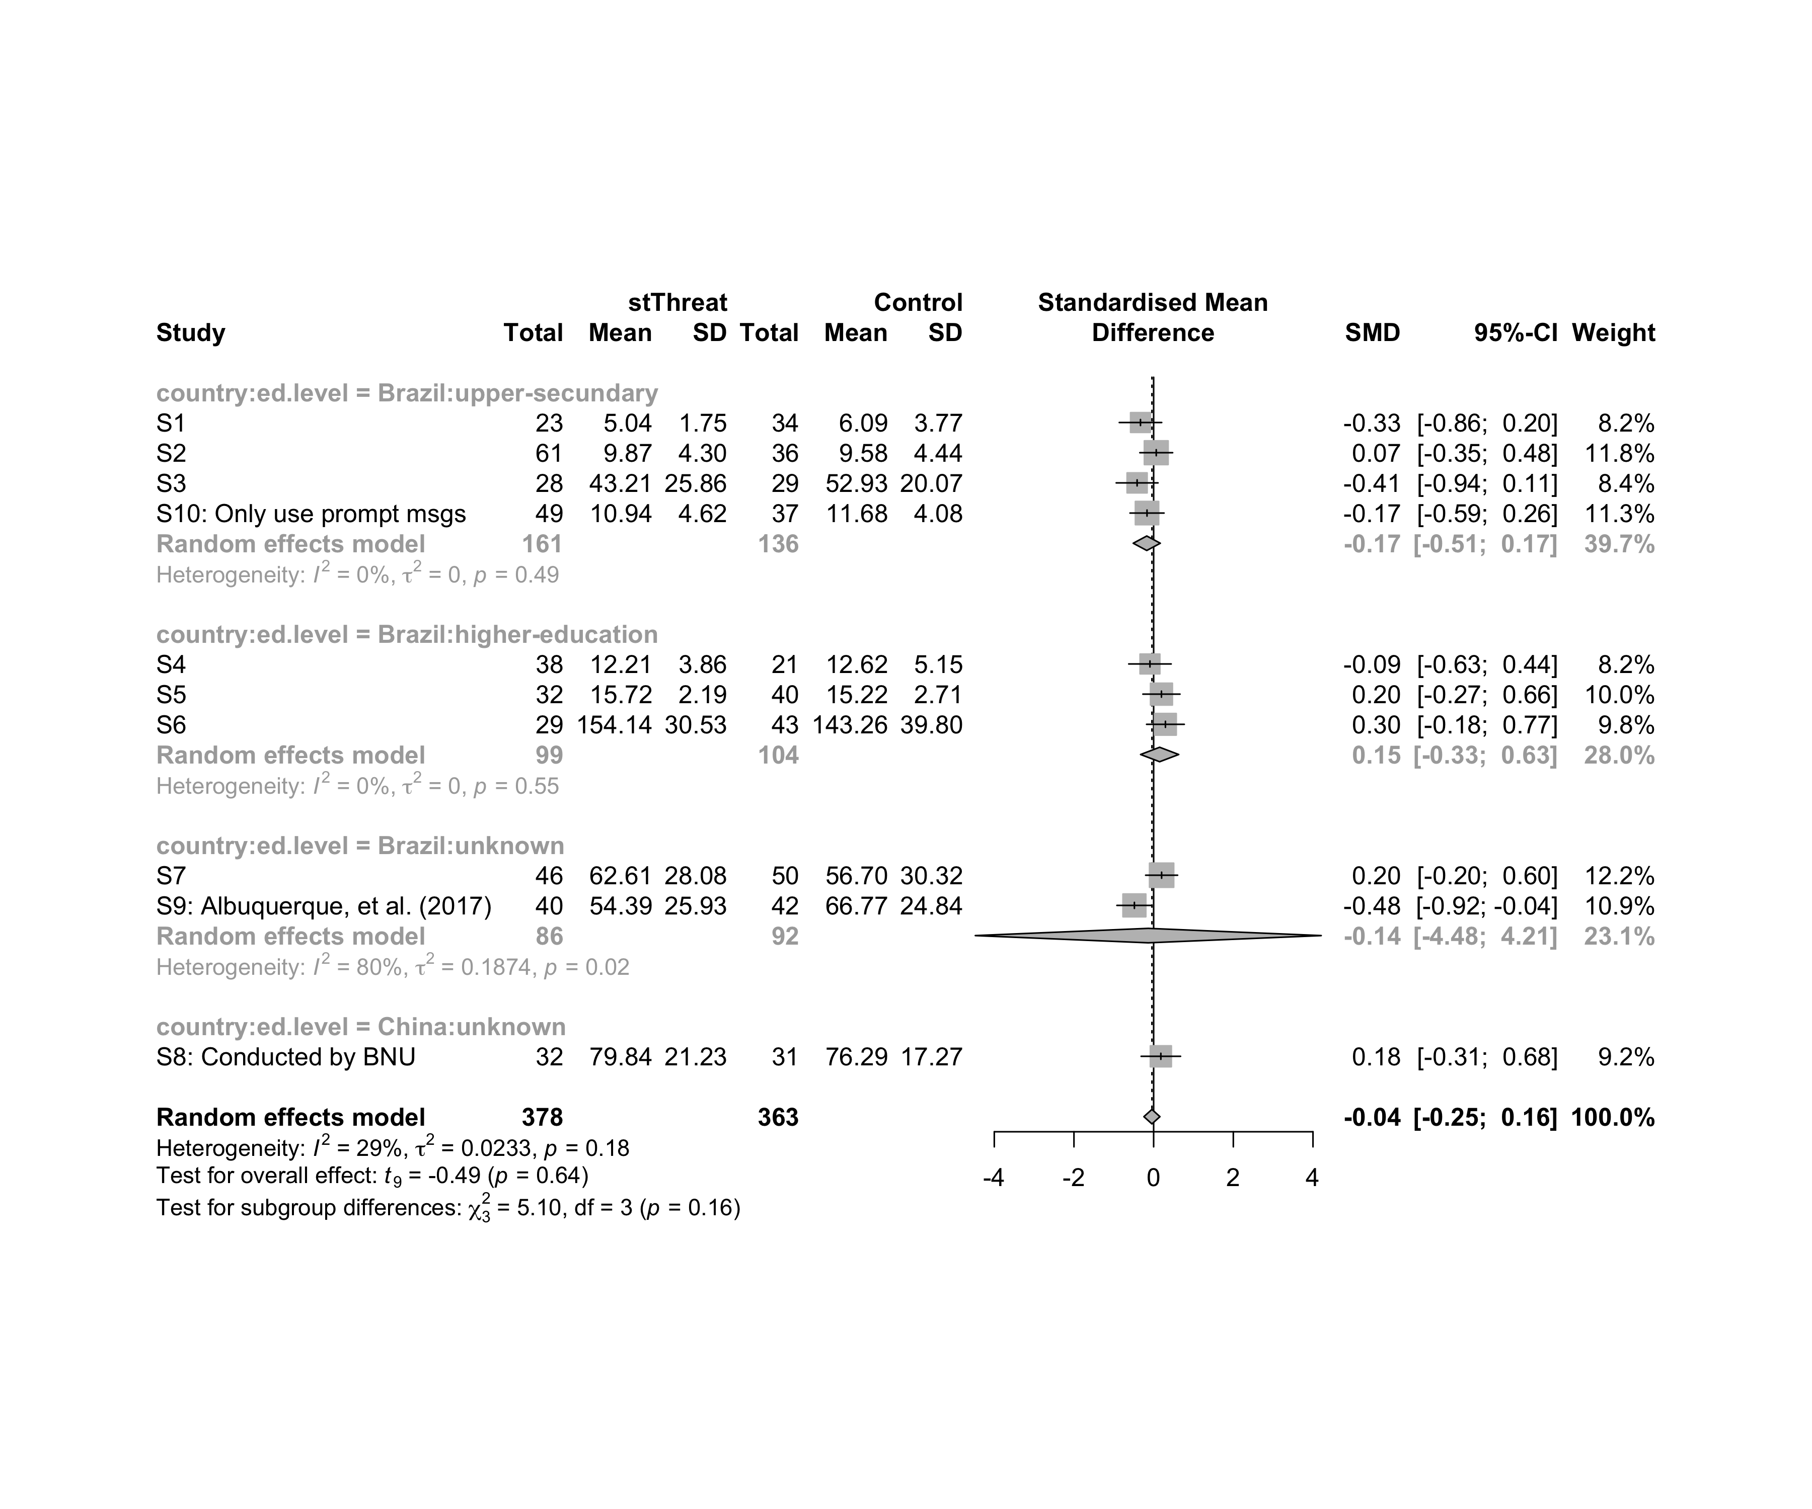

### Subgroup analysis by “country:intervention”

m.sg4sub <- update.meta(m.cont, subgroup = `country:intervention`, random = T, fixed = F)  
summary(m.sg4sub)

## Review: Performance in stThreat  
##   
## SMD 95%-CI %W(random)  
## S1 -0.3302 [-0.8631; 0.2026] 8.2  
## S2 0.0653 [-0.3468; 0.4773] 11.8  
## S3 -0.4150 [-0.9402; 0.1103] 8.4  
## S4 -0.0924 [-0.6256; 0.4408] 8.2  
## S5 0.1959 [-0.2701; 0.6619] 10.0  
## S6 0.2959 [-0.1777; 0.7695] 9.8  
## S7 0.2003 [-0.2012; 0.6017] 12.2  
## S8: Conducted by BNU 0.1809 [-0.3141; 0.6759] 9.2  
## S9: Albuquerque, et al. (2017) -0.4832 [-0.9228; -0.0436] 10.9  
## S10: Only use prompt msgs -0.1663 [-0.5939; 0.2614] 11.3  
## country:intervention  
## S1 Brazil:Gender-stereotype color, ranking, badges, and avatar  
## S2 Brazil:Gender-stereotype color, ranking, badges, and avatar  
## S3 Brazil:Gender-stereotype color, ranking, badges, and avatar  
## S4 Brazil:Gender-stereotype color, ranking, badges, and avatar  
## S5 Brazil:Gender-stereotype color, ranking, badges, and avatar  
## S6 Brazil:Gender-stereotype color, ranking, badges, and avatar  
## S7 Brazil:Gender-stereotype color, ranking, badges, and avatar  
## S8: Conducted by BNU China:Gender-stereotype color, ranking, badges, and avatar  
## S9: Albuquerque, et al. (2017) Brazil:Gender-stereotype color, ranking, badges, and avatar  
## S10: Only use prompt msgs Brazil:Gender-stereotyped motivational message prompts  
##   
## Number of studies combined: k = 10  
## Number of observations: o = 741  
##   
## SMD 95%-CI t p-value  
## Random effects model -0.0434 [-0.2450; 0.1583] -0.49 0.6382  
##   
## Quantifying heterogeneity:  
## tau^2 = 0.0233 [0.0000; 0.2097]; tau = 0.1525 [0.0000; 0.4579]  
## I^2 = 29.0% [0.0%; 66.0%]; H = 1.19 [1.00; 1.72]  
##   
## Test of heterogeneity:  
## Q d.f. p-value  
## 12.68 9 0.1775  
##   
## Results for subgroups (random effects model):  
## k SMD 95%-CI tau^2 tau Q  
## country:intervention = Brazil:Gender-stereotype color, ... 8 -0.0546 [-0.3105; 0.2013] 0.0377 0.1942 11.58  
## country:intervention = China:Gender-stereotype color, ... 1 0.1809 [-0.3141; 0.6759] -- -- 0.00  
## country:intervention = Brazil:Gender-stereotyped motiv ... 1 -0.1663 [-0.5939; 0.2614] -- -- 0.00  
## I^2  
## country:intervention = Brazil:Gender-stereotype color, ... 39.6%  
## country:intervention = China:Gender-stereotype color, ... --  
## country:intervention = Brazil:Gender-stereotyped motiv ... --  
##   
## Test for subgroup differences (random effects model):  
## Q d.f. p-value  
## Between groups 1.12 2 0.5722  
##   
## Details on meta-analytical method:  
## - Inverse variance method  
## - Restricted maximum-likelihood estimator for tau^2  
## - Q-profile method for confidence interval of tau^2 and tau  
## - Hartung-Knapp adjustment for random effects model  
## - Hedges' g (bias corrected standardised mean difference; using exact formulae)

forest(m.sg4sub, digits=2, digits.sd = 2, test.overall = T, label.e = cond)

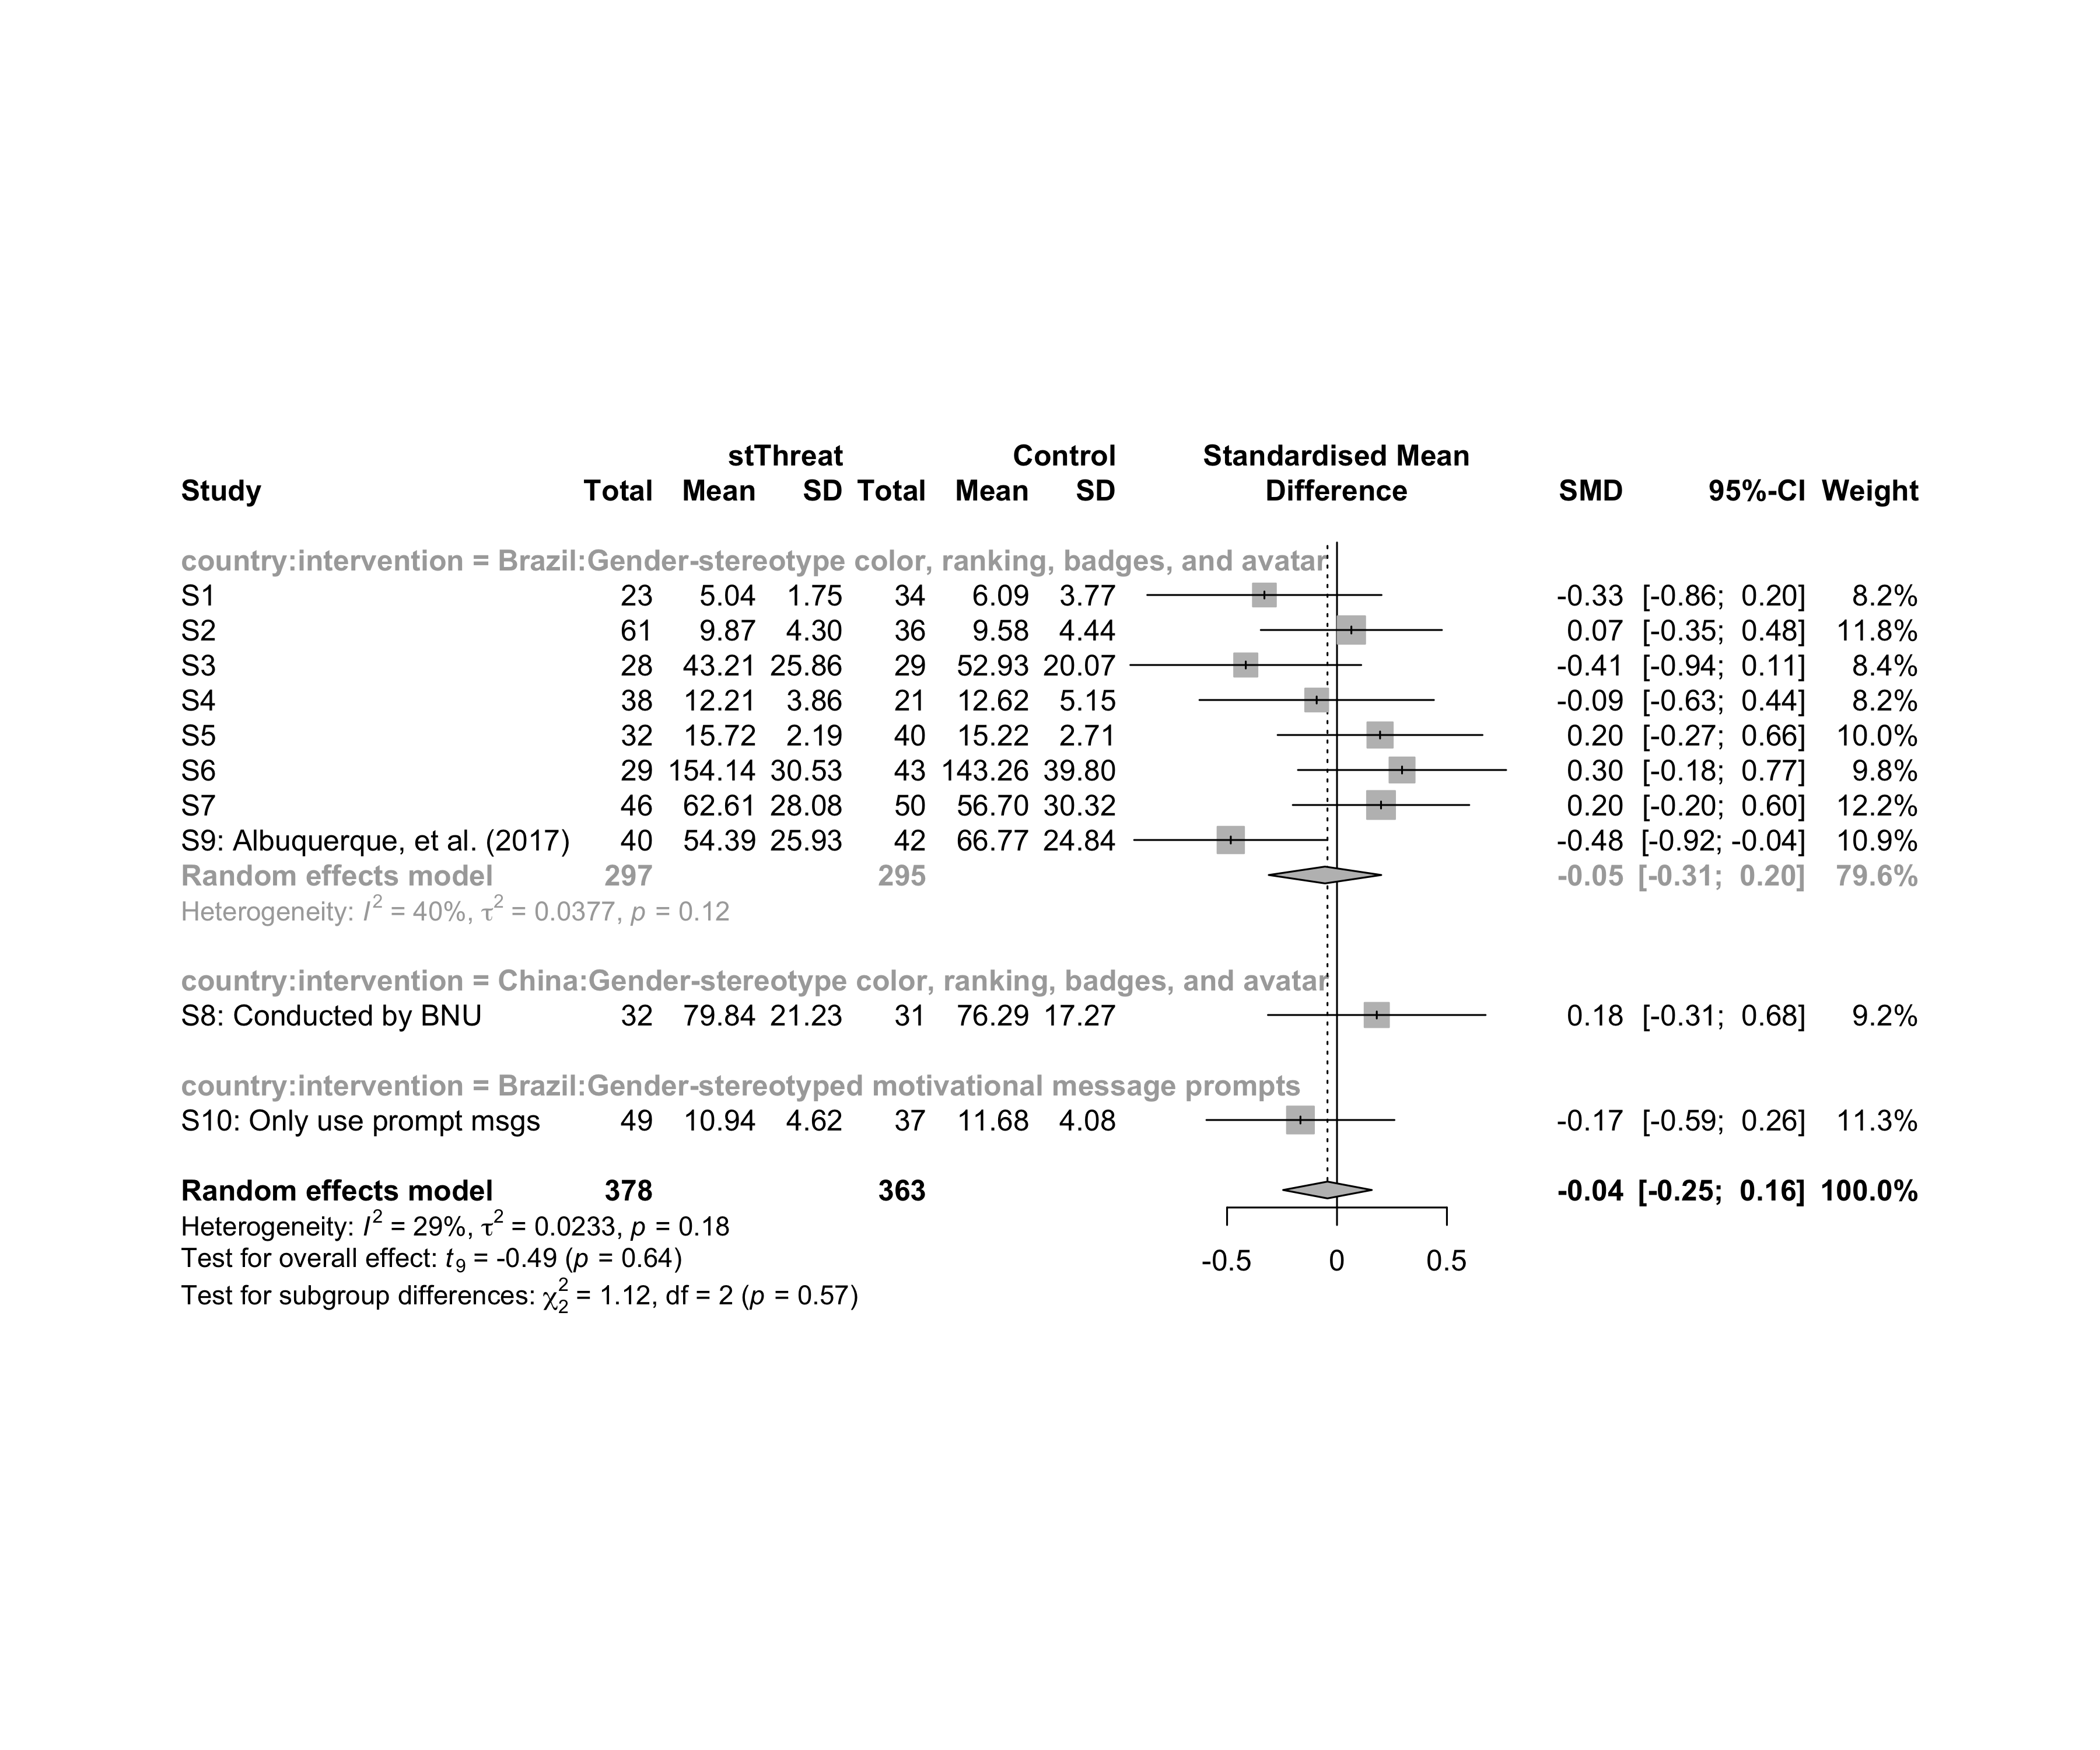

### Subgroup analysis by “age:intervention”

m.sg4sub <- update.meta(m.cont, subgroup = `age:intervention`, random = T, fixed = F)  
summary(m.sg4sub)

## Review: Performance in stThreat  
##   
## SMD 95%-CI %W(random)  
## S1 -0.3302 [-0.8631; 0.2026] 8.2  
## S2 0.0653 [-0.3468; 0.4773] 11.8  
## S3 -0.4150 [-0.9402; 0.1103] 8.4  
## S4 -0.0924 [-0.6256; 0.4408] 8.2  
## S5 0.1959 [-0.2701; 0.6619] 10.0  
## S6 0.2959 [-0.1777; 0.7695] 9.8  
## S7 0.2003 [-0.2012; 0.6017] 12.2  
## S8: Conducted by BNU 0.1809 [-0.3141; 0.6759] 9.2  
## S9: Albuquerque, et al. (2017) -0.4832 [-0.9228; -0.0436] 10.9  
## S10: Only use prompt msgs -0.1663 [-0.5939; 0.2614] 11.3  
## age:intervention  
## S1 adolescent:Gender-stereotype color, ranking, badges, and avatar  
## S2 adolescent:Gender-stereotype color, ranking, badges, and avatar  
## S3 adolescent:Gender-stereotype color, ranking, badges, and avatar  
## S4 adult:Gender-stereotype color, ranking, badges, and avatar  
## S5 adult:Gender-stereotype color, ranking, badges, and avatar  
## S6 adult:Gender-stereotype color, ranking, badges, and avatar  
## S7 adult:Gender-stereotype color, ranking, badges, and avatar  
## S8: Conducted by BNU no-restriction:Gender-stereotype color, ranking, badges, and avatar  
## S9: Albuquerque, et al. (2017) no-restriction:Gender-stereotype color, ranking, badges, and avatar  
## S10: Only use prompt msgs adolescence:Gender-stereotyped motivational message prompts  
##   
## Number of studies combined: k = 10  
## Number of observations: o = 741  
##   
## SMD 95%-CI t p-value  
## Random effects model -0.0434 [-0.2450; 0.1583] -0.49 0.6382  
##   
## Quantifying heterogeneity:  
## tau^2 = 0.0233 [0.0000; 0.2097]; tau = 0.1525 [0.0000; 0.4579]  
## I^2 = 29.0% [0.0%; 66.0%]; H = 1.19 [1.00; 1.72]  
##   
## Test of heterogeneity:  
## Q d.f. p-value  
## 12.68 9 0.1775  
##   
## Results for subgroups (random effects model):  
## k SMD 95%-CI tau^2 tau Q  
## age:intervention = adolescent:Gender-stereotype co ... 3 -0.1887 [-0.8543; 0.4770] 0.0191 0.1382 2.43  
## age:intervention = adult:Gender-stereotype color, ... 4 0.1671 [-0.0733; 0.4075] 0 0 1.24  
## age:intervention = no-restriction:Gender-stereotyp ... 2 -0.1613 [-4.3784; 4.0558] 0.1635 0.4043 3.87  
## age:intervention = adolescence:Gender-stereotyped ... 1 -0.1663 [-0.5939; 0.2614] -- -- 0.00  
## I^2  
## age:intervention = adolescent:Gender-stereotype co ... 17.8%  
## age:intervention = adult:Gender-stereotype color, ... 0.0%  
## age:intervention = no-restriction:Gender-stereotyp ... 74.1%  
## age:intervention = adolescence:Gender-stereotyped ... --  
##   
## Test for subgroup differences (random effects model):  
## Q d.f. p-value  
## Between groups 6.10 3 0.1067  
##   
## Details on meta-analytical method:  
## - Inverse variance method  
## - Restricted maximum-likelihood estimator for tau^2  
## - Q-profile method for confidence interval of tau^2 and tau  
## - Hartung-Knapp adjustment for random effects model  
## - Hedges' g (bias corrected standardised mean difference; using exact formulae)

forest(m.sg4sub, digits=2, digits.sd = 2, test.overall = T, label.e = cond)

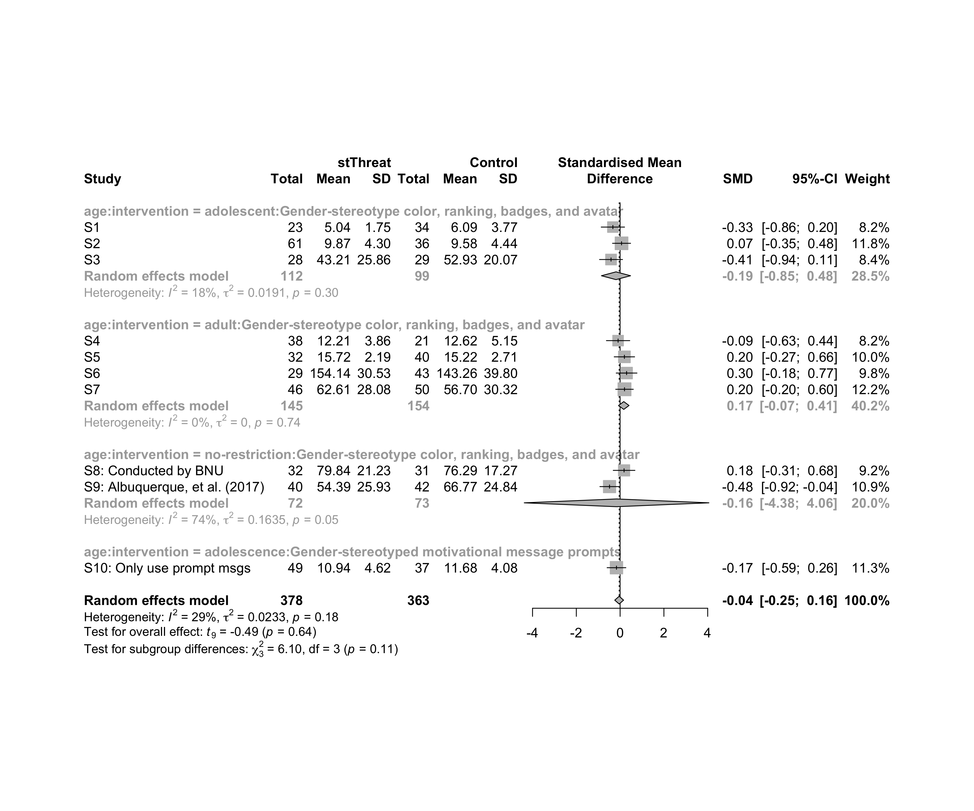

### Subgroup analysis by “ed.level:intervention”

m.sg4sub <- update.meta(m.cont, subgroup = `ed.level:intervention`, random = T, fixed = F)  
summary(m.sg4sub)

## Review: Performance in stThreat  
##   
## SMD 95%-CI %W(random)  
## S1 -0.3302 [-0.8631; 0.2026] 8.2  
## S2 0.0653 [-0.3468; 0.4773] 11.8  
## S3 -0.4150 [-0.9402; 0.1103] 8.4  
## S4 -0.0924 [-0.6256; 0.4408] 8.2  
## S5 0.1959 [-0.2701; 0.6619] 10.0  
## S6 0.2959 [-0.1777; 0.7695] 9.8  
## S7 0.2003 [-0.2012; 0.6017] 12.2  
## S8: Conducted by BNU 0.1809 [-0.3141; 0.6759] 9.2  
## S9: Albuquerque, et al. (2017) -0.4832 [-0.9228; -0.0436] 10.9  
## S10: Only use prompt msgs -0.1663 [-0.5939; 0.2614] 11.3  
## ed.level:intervention  
## S1 upper-secundary:Gender-stereotype color, ranking, badges, and avatar  
## S2 upper-secundary:Gender-stereotype color, ranking, badges, and avatar  
## S3 upper-secundary:Gender-stereotype color, ranking, badges, and avatar  
## S4 higher-education:Gender-stereotype color, ranking, badges, and avatar  
## S5 higher-education:Gender-stereotype color, ranking, badges, and avatar  
## S6 higher-education:Gender-stereotype color, ranking, badges, and avatar  
## S7 unknown:Gender-stereotype color, ranking, badges, and avatar  
## S8: Conducted by BNU unknown:Gender-stereotype color, ranking, badges, and avatar  
## S9: Albuquerque, et al. (2017) unknown:Gender-stereotype color, ranking, badges, and avatar  
## S10: Only use prompt msgs upper-secundary:Gender-stereotyped motivational message prompts  
##   
## Number of studies combined: k = 10  
## Number of observations: o = 741  
##   
## SMD 95%-CI t p-value  
## Random effects model -0.0434 [-0.2450; 0.1583] -0.49 0.6382  
##   
## Quantifying heterogeneity:  
## tau^2 = 0.0233 [0.0000; 0.2097]; tau = 0.1525 [0.0000; 0.4579]  
## I^2 = 29.0% [0.0%; 66.0%]; H = 1.19 [1.00; 1.72]  
##   
## Test of heterogeneity:  
## Q d.f. p-value  
## 12.68 9 0.1775  
##   
## Results for subgroups (random effects model):  
## k SMD 95%-CI tau^2 tau Q  
## ed.level:intervention = upper-secundary:Gender-stereoty ... 3 -0.1887 [-0.8543; 0.4770] 0.0191 0.1382 2.43  
## ed.level:intervention = higher-education:Gender-stereot ... 3 0.1507 [-0.3279; 0.6294] 0 0 1.20  
## ed.level:intervention = unknown:Gender-stereotype color ... 3 -0.0353 [-1.0048; 0.9342] 0.1022 0.3197 6.04  
## ed.level:intervention = upper-secundary:Gender-stereoty ... 1 -0.1663 [-0.5939; 0.2614] -- -- 0.00  
## I^2  
## ed.level:intervention = upper-secundary:Gender-stereoty ... 17.8%  
## ed.level:intervention = higher-education:Gender-stereot ... 0.0%  
## ed.level:intervention = unknown:Gender-stereotype color ... 66.9%  
## ed.level:intervention = upper-secundary:Gender-stereoty ... --  
##   
## Test for subgroup differences (random effects model):  
## Q d.f. p-value  
## Between groups 3.93 3 0.2693  
##   
## Details on meta-analytical method:  
## - Inverse variance method  
## - Restricted maximum-likelihood estimator for tau^2  
## - Q-profile method for confidence interval of tau^2 and tau  
## - Hartung-Knapp adjustment for random effects model  
## - Hedges' g (bias corrected standardised mean difference; using exact formulae)

forest(m.sg4sub, digits=2, digits.sd = 2, test.overall = T, label.e = cond)

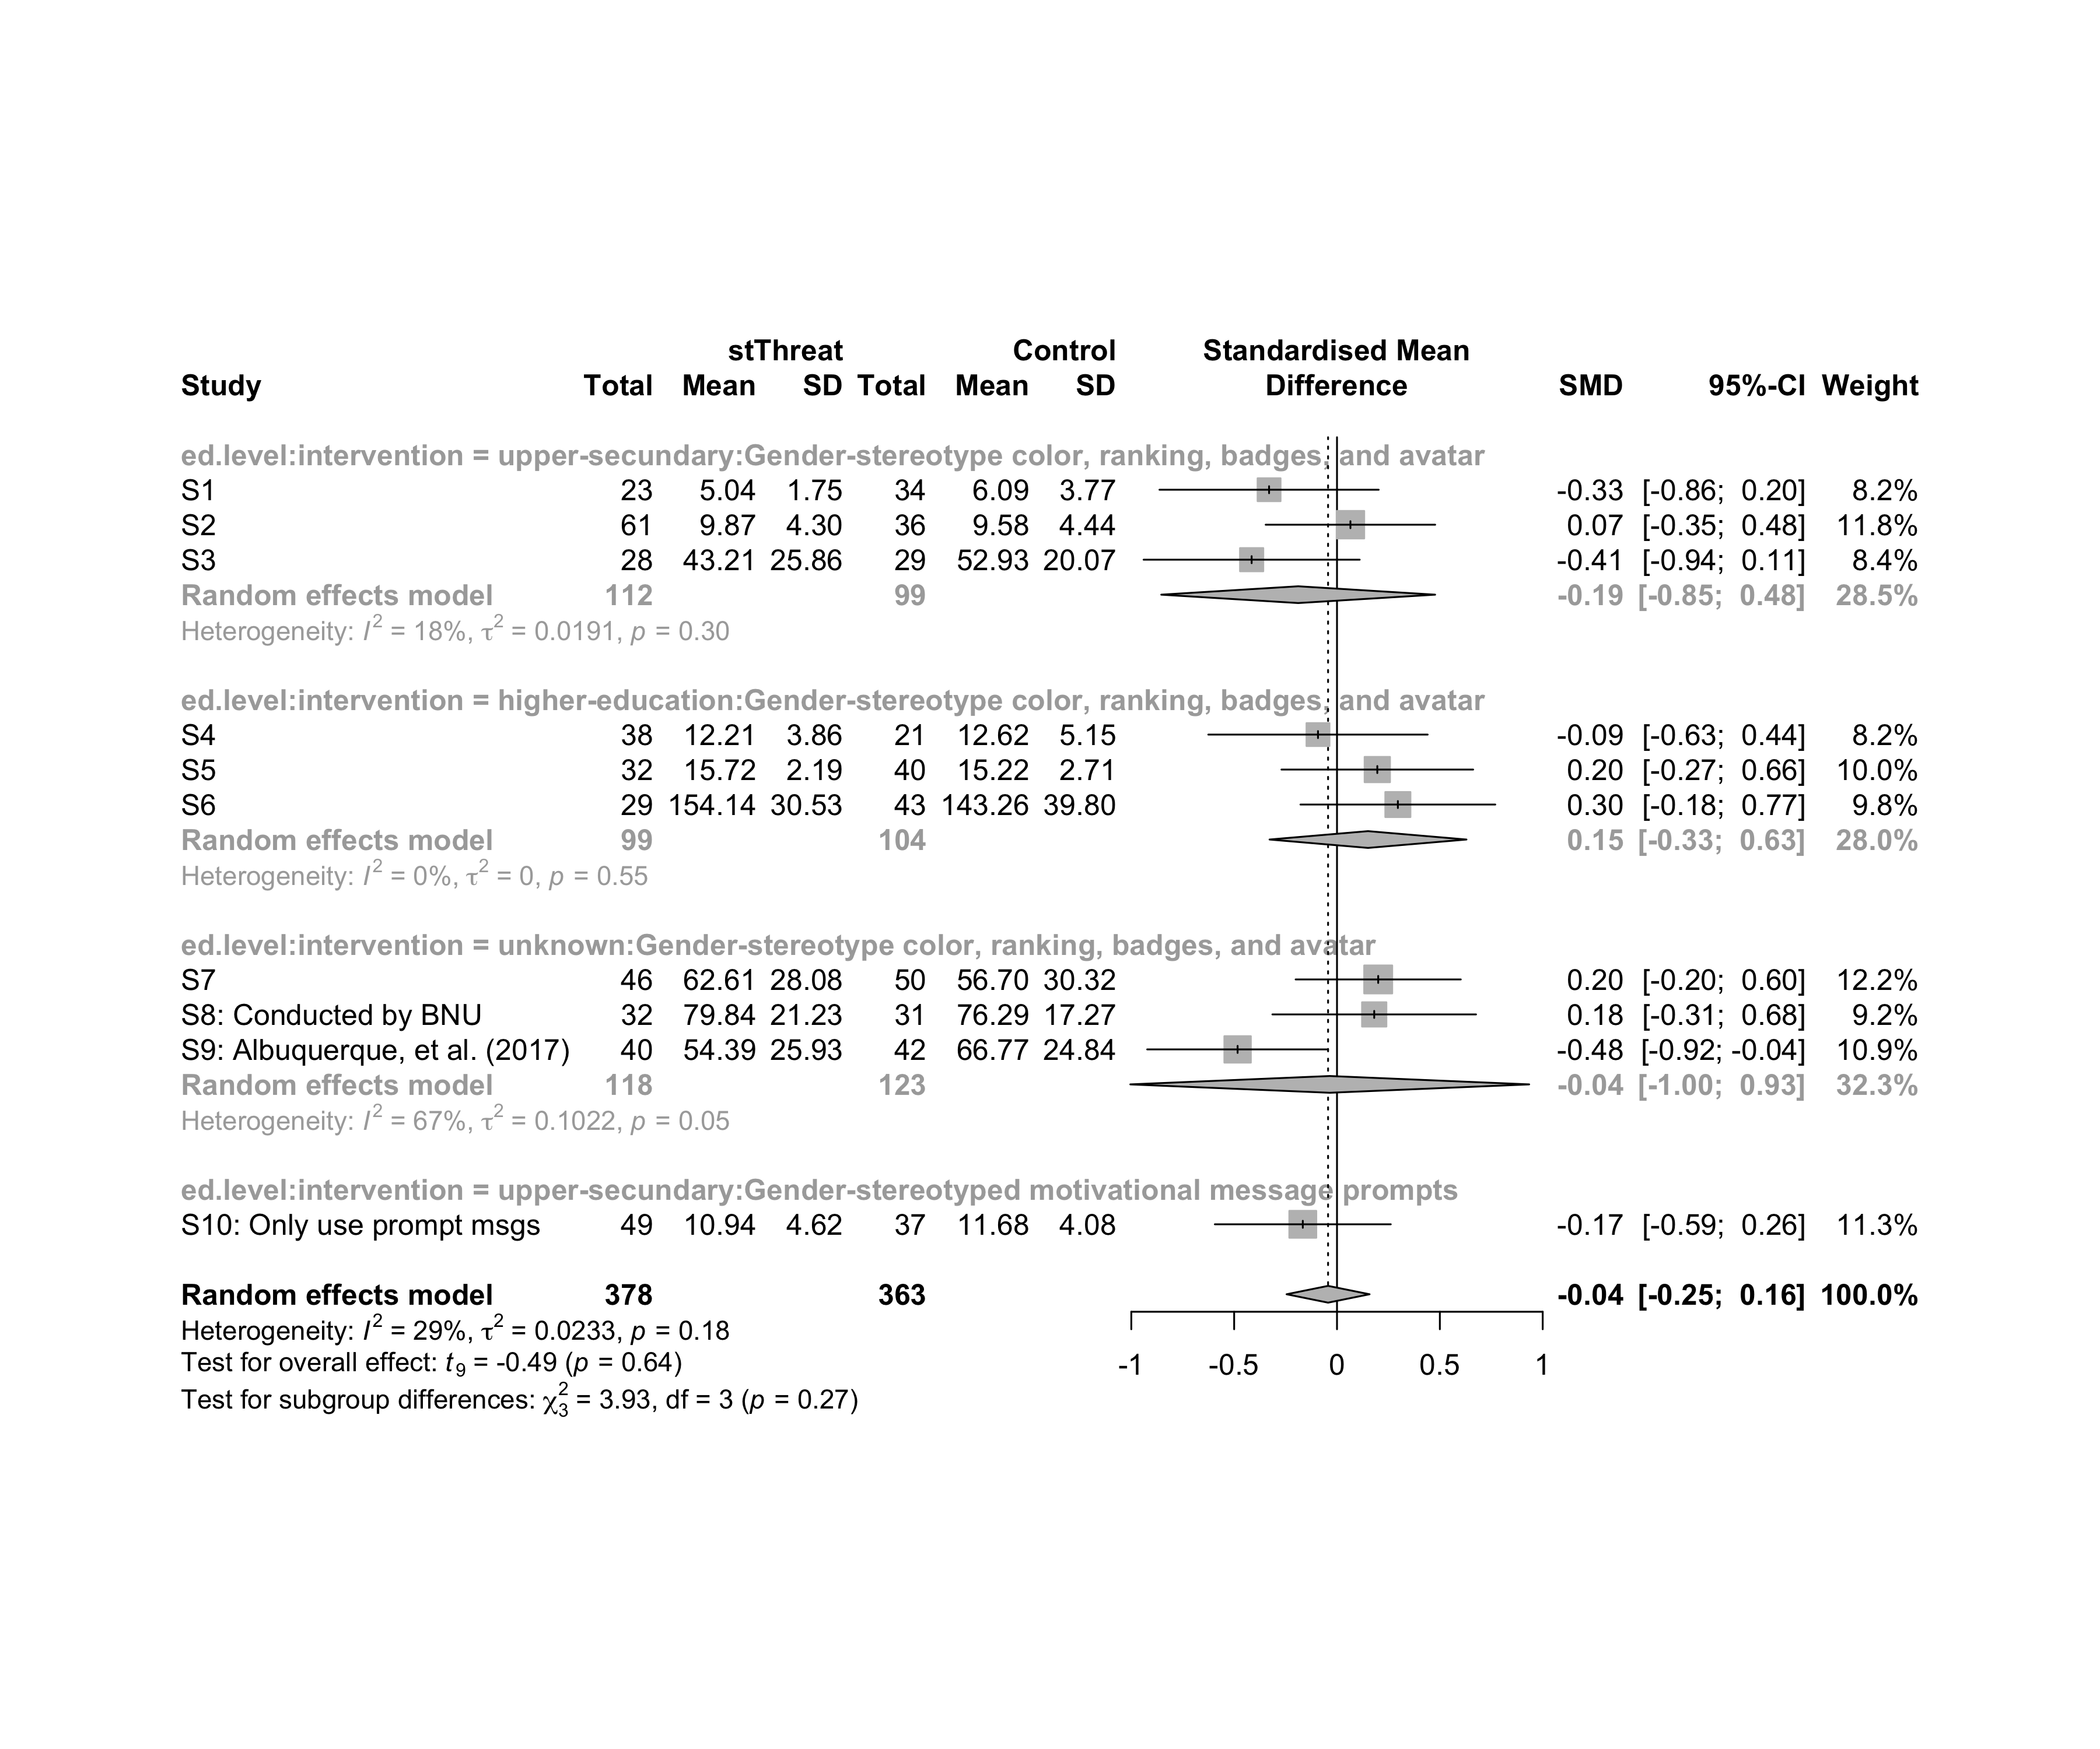

### Subgroup analysis by “country:age:intervention”

m.sg4sub <- update.meta(m.cont, subgroup = `country:age:intervention`, random = T, fixed = F)  
summary(m.sg4sub)

## Review: Performance in stThreat  
##   
## SMD 95%-CI %W(random)  
## S1 -0.3302 [-0.8631; 0.2026] 8.2  
## S2 0.0653 [-0.3468; 0.4773] 11.8  
## S3 -0.4150 [-0.9402; 0.1103] 8.4  
## S4 -0.0924 [-0.6256; 0.4408] 8.2  
## S5 0.1959 [-0.2701; 0.6619] 10.0  
## S6 0.2959 [-0.1777; 0.7695] 9.8  
## S7 0.2003 [-0.2012; 0.6017] 12.2  
## S8: Conducted by BNU 0.1809 [-0.3141; 0.6759] 9.2  
## S9: Albuquerque, et al. (2017) -0.4832 [-0.9228; -0.0436] 10.9  
## S10: Only use prompt msgs -0.1663 [-0.5939; 0.2614] 11.3  
## country:age:intervention  
## S1 Brazil:adolescent:Gender-stereotype color, ranking, badges, and avatar  
## S2 Brazil:adolescent:Gender-stereotype color, ranking, badges, and avatar  
## S3 Brazil:adolescent:Gender-stereotype color, ranking, badges, and avatar  
## S4 Brazil:adult:Gender-stereotype color, ranking, badges, and avatar  
## S5 Brazil:adult:Gender-stereotype color, ranking, badges, and avatar  
## S6 Brazil:adult:Gender-stereotype color, ranking, badges, and avatar  
## S7 Brazil:adult:Gender-stereotype color, ranking, badges, and avatar  
## S8: Conducted by BNU China:no-restriction:Gender-stereotype color, ranking, badges, and avatar  
## S9: Albuquerque, et al. (2017) Brazil:no-restriction:Gender-stereotype color, ranking, badges, and avatar  
## S10: Only use prompt msgs Brazil:adolescence:Gender-stereotyped motivational message prompts  
##   
## Number of studies combined: k = 10  
## Number of observations: o = 741  
##   
## SMD 95%-CI t p-value  
## Random effects model -0.0434 [-0.2450; 0.1583] -0.49 0.6382  
##   
## Quantifying heterogeneity:  
## tau^2 = 0.0233 [0.0000; 0.2097]; tau = 0.1525 [0.0000; 0.4579]  
## I^2 = 29.0% [0.0%; 66.0%]; H = 1.19 [1.00; 1.72]  
##   
## Test of heterogeneity:  
## Q d.f. p-value  
## 12.68 9 0.1775  
##   
## Results for subgroups (random effects model):  
## k SMD 95%-CI tau^2 tau  
## country:age:intervention = Brazil:adolescent:Gender-stereo ... 3 -0.1887 [-0.8543; 0.4770] 0.0191 0.1382  
## country:age:intervention = Brazil:adult:Gender-stereotype ... 4 0.1671 [-0.0733; 0.4075] 0 0  
## country:age:intervention = China:no-restriction:Gender-ste ... 1 0.1809 [-0.3141; 0.6759] -- --  
## country:age:intervention = Brazil:no-restriction:Gender-st ... 1 -0.4832 [-0.9228; -0.0436] -- --  
## country:age:intervention = Brazil:adolescence:Gender-stere ... 1 -0.1663 [-0.5939; 0.2614] -- --  
## Q I^2  
## country:age:intervention = Brazil:adolescent:Gender-stereo ... 2.43 17.8%  
## country:age:intervention = Brazil:adult:Gender-stereotype ... 1.24 0.0%  
## country:age:intervention = China:no-restriction:Gender-ste ... 0.00 --  
## country:age:intervention = Brazil:no-restriction:Gender-st ... 0.00 --  
## country:age:intervention = Brazil:adolescence:Gender-stere ... 0.00 --  
##   
## Test for subgroup differences (random effects model):  
## Q d.f. p-value  
## Between groups 11.66 4 0.0200  
##   
## Details on meta-analytical method:  
## - Inverse variance method  
## - Restricted maximum-likelihood estimator for tau^2  
## - Q-profile method for confidence interval of tau^2 and tau  
## - Hartung-Knapp adjustment for random effects model  
## - Hedges' g (bias corrected standardised mean difference; using exact formulae)

forest(m.sg4sub, digits=2, digits.sd = 2, test.overall = T, label.e = cond)

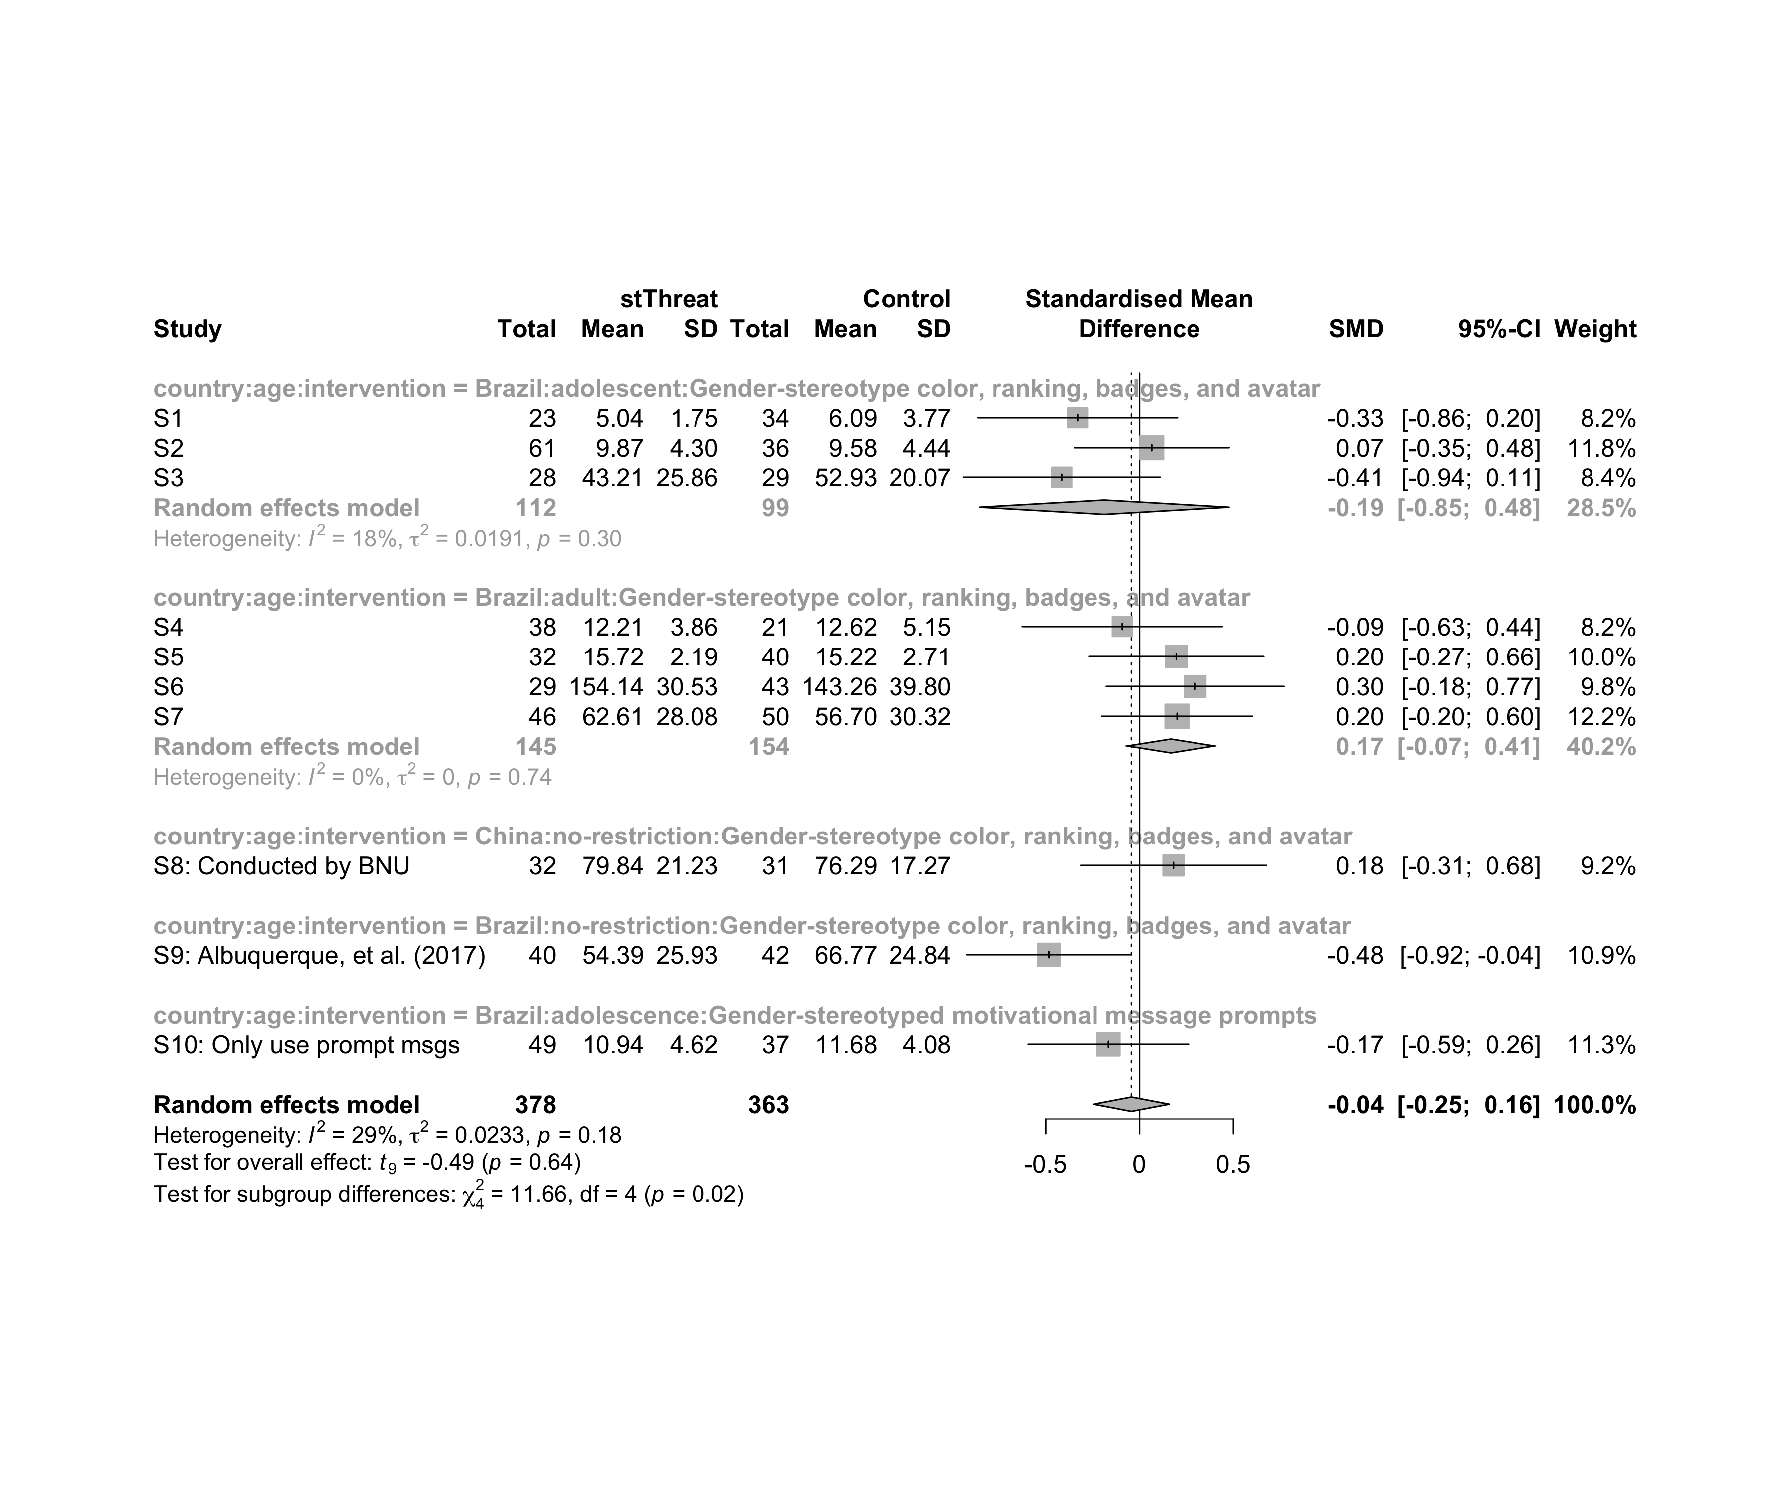

### Subgroup analysis by “country:ed.level:intervention”

m.sg4sub <- update.meta(m.cont, subgroup = `country:ed.level:intervention`, random = T, fixed = F)  
summary(m.sg4sub)

## Review: Performance in stThreat  
##   
## SMD 95%-CI %W(random)  
## S1 -0.3302 [-0.8631; 0.2026] 8.2  
## S2 0.0653 [-0.3468; 0.4773] 11.8  
## S3 -0.4150 [-0.9402; 0.1103] 8.4  
## S4 -0.0924 [-0.6256; 0.4408] 8.2  
## S5 0.1959 [-0.2701; 0.6619] 10.0  
## S6 0.2959 [-0.1777; 0.7695] 9.8  
## S7 0.2003 [-0.2012; 0.6017] 12.2  
## S8: Conducted by BNU 0.1809 [-0.3141; 0.6759] 9.2  
## S9: Albuquerque, et al. (2017) -0.4832 [-0.9228; -0.0436] 10.9  
## S10: Only use prompt msgs -0.1663 [-0.5939; 0.2614] 11.3  
## country:ed.level:intervention  
## S1 Brazil:upper-secundary:Gender-stereotype color, ranking, badges, and avatar  
## S2 Brazil:upper-secundary:Gender-stereotype color, ranking, badges, and avatar  
## S3 Brazil:upper-secundary:Gender-stereotype color, ranking, badges, and avatar  
## S4 Brazil:higher-education:Gender-stereotype color, ranking, badges, and avatar  
## S5 Brazil:higher-education:Gender-stereotype color, ranking, badges, and avatar  
## S6 Brazil:higher-education:Gender-stereotype color, ranking, badges, and avatar  
## S7 Brazil:unknown:Gender-stereotype color, ranking, badges, and avatar  
## S8: Conducted by BNU China:unknown:Gender-stereotype color, ranking, badges, and avatar  
## S9: Albuquerque, et al. (2017) Brazil:unknown:Gender-stereotype color, ranking, badges, and avatar  
## S10: Only use prompt msgs Brazil:upper-secundary:Gender-stereotyped motivational message prompts  
##   
## Number of studies combined: k = 10  
## Number of observations: o = 741  
##   
## SMD 95%-CI t p-value  
## Random effects model -0.0434 [-0.2450; 0.1583] -0.49 0.6382  
##   
## Quantifying heterogeneity:  
## tau^2 = 0.0233 [0.0000; 0.2097]; tau = 0.1525 [0.0000; 0.4579]  
## I^2 = 29.0% [0.0%; 66.0%]; H = 1.19 [1.00; 1.72]  
##   
## Test of heterogeneity:  
## Q d.f. p-value  
## 12.68 9 0.1775  
##   
## Results for subgroups (random effects model):  
## k SMD 95%-CI tau^2  
## country:ed.level:intervention = Brazil:upper-secundary:Gender-s ... 3 -0.1887 [-0.8543; 0.4770] 0.0191  
## country:ed.level:intervention = Brazil:higher-education:Gender- ... 3 0.1507 [-0.3279; 0.6294] 0  
## country:ed.level:intervention = Brazil:unknown:Gender-stereotyp ... 2 -0.1353 [-4.4768; 4.2061] 0.1874  
## country:ed.level:intervention = China:unknown:Gender-stereotype ... 1 0.1809 [-0.3141; 0.6759] --  
## country:ed.level:intervention = Brazil:upper-secundary:Gender-s ... 1 -0.1663 [-0.5939; 0.2614] --  
## tau Q I^2  
## country:ed.level:intervention = Brazil:upper-secundary:Gender-s ... 0.1382 2.43 17.8%  
## country:ed.level:intervention = Brazil:higher-education:Gender- ... 0 1.20 0.0%  
## country:ed.level:intervention = Brazil:unknown:Gender-stereotyp ... 0.4329 5.06 80.3%  
## country:ed.level:intervention = China:unknown:Gender-stereotype ... -- 0.00 --  
## country:ed.level:intervention = Brazil:upper-secundary:Gender-s ... -- 0.00 --  
##   
## Test for subgroup differences (random effects model):  
## Q d.f. p-value  
## Between groups 4.54 4 0.3381  
##   
## Details on meta-analytical method:  
## - Inverse variance method  
## - Restricted maximum-likelihood estimator for tau^2  
## - Q-profile method for confidence interval of tau^2 and tau  
## - Hartung-Knapp adjustment for random effects model  
## - Hedges' g (bias corrected standardised mean difference; using exact formulae)

forest(m.sg4sub, digits=2, digits.sd = 2, test.overall = T, label.e = cond)

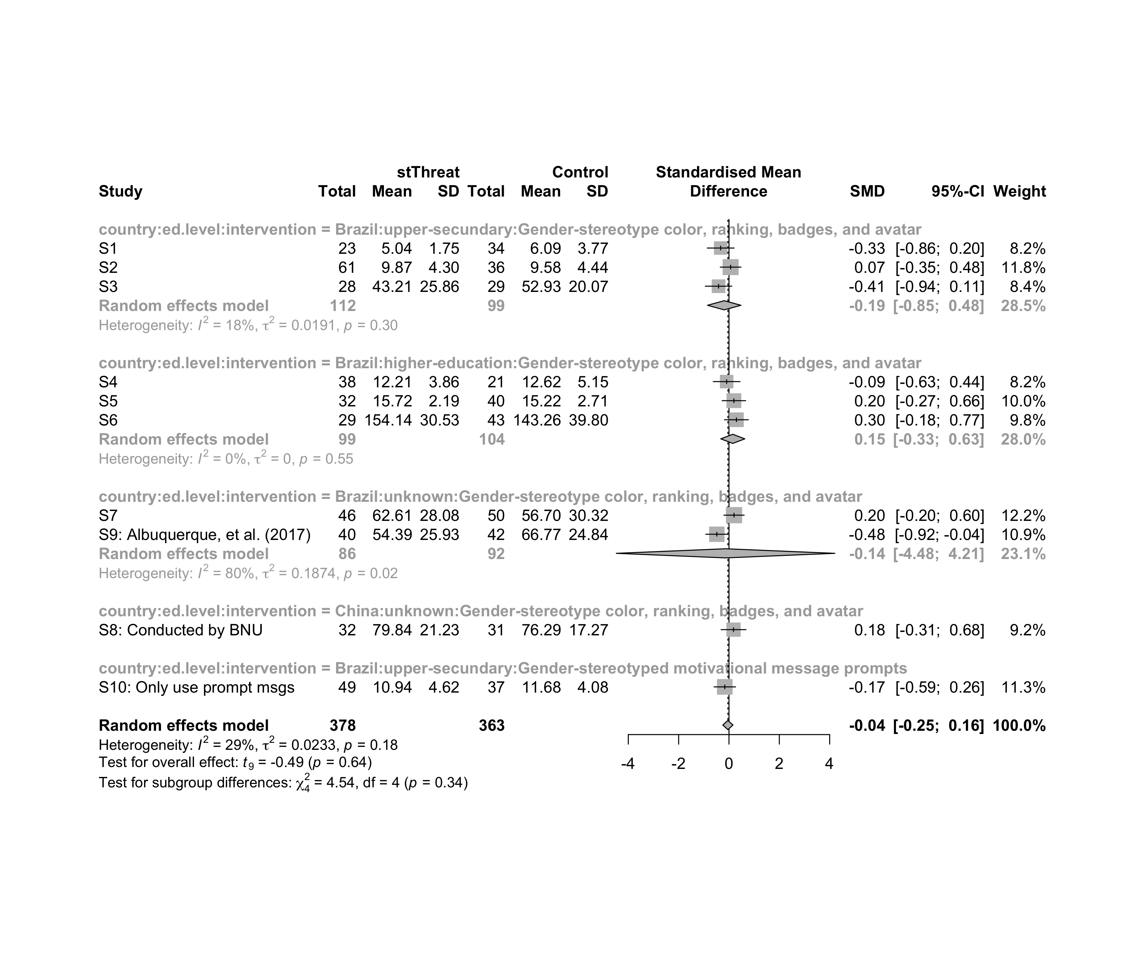

## Funnel Plot

m.cont <- update.meta(m.cont, studlab = data$study)  
summary(eggers.test(x = m.cont))

## Eggers' test of the intercept   
## =============================   
##   
## intercept 95% CI t p  
## -3.205 -10.62 - 4.21 -0.847 0.42  
##   
## Eggers' test does not indicate the presence of funnel plot asymmetry.

funnel(m.cont, xlab = "Hedges' g", studlab = T, legend=T, addtau2 = T)

